**Egyptian E-Learning University**

Faculty of Computers & Information Technology

Recipe Recommendation System

**By**

|  |  |
| --- | --- |
| Yousef Emad Mikhail | 2101716 |
| Waseam Nashat Samir | 2101680 |
| Ahmed Refat Mohamed | 2101827 |
| Ahmed Nageh Mohamed | 2100347 |
| Souhaila Alaa | 2101651 |
| Vronia Medhat Sedky | 2101673 |
| Abdelrahman Helal | 2100303 |

Supervised by  
**Dr.** **Yasser** **Abdelfattah**

Assistant  
**Eng.** **Hayam Abdelbaset**  
  
Sohag-2025

Abstract

**Recolored** is a cross-platform application designed to assist users in discovering and preparing meals based on the ingredients they already have. It consists of a **Flutter mobile app**, a **React web application**, and a **Node.js backend**. The system leverages an intelligent **chatbot** that interacts with the user to suggest appropriate recipes using available components in their kitchen. Additionally, users can view categorized recipes, check detailed ingredient lists, and follow step-by-step cooking instructions.

One of the main features of the system is the ability to **shop online for missing ingredients**, streamlining the cooking process, and enhancing user convenience. The app aims to reduce food waste, save time, and inspire users to cook more efficiently. It includes a **clean, user-friendly interface** with support for **multiple platforms and screen sizes**, ensuring accessibility for a wide range of users.

By providing personalized recipe suggestions and integrated shopping capabilities, **Recipes** contributes to healthier eating habits, better kitchen management, and a smarter lifestyle. The system reflects the potential of combining AI with daily life needs to create practical, intelligent digital solutions.

**Acknowledgments**

First, we want to thank God for his grace and support throughout our college years and our graduation project to complete this stage of our life successfully. We have put efforts into this project. However, this was not enough without the support of many individuals and

organizations, and the assistance of the Egyptian University for E-learning, especially the **Sohag Center,** is helping us to reach this level of awareness. We would like to express our deep gratitude to our Project Supervisor, **Dr.** **Yasser** **Abdelfattah,** for following us and guiding this project. We are also especially indebted to expressing our thanks to **Eng.** **Hayam Abdelbaset** for her constant guidance and supervision. Finally, we would like to express our gratitude to everyone who helped us with the graduation project.

**Contents**

Abstract 2

Acknowledgments 3

Introduction 5

Literature Review / Related Work 7

Proposed system 9

Implementation 11

Testing & Evaluation 13

Results & Discussion 15

Conclusion & Future Work 17

References 19

Appendices (Optional) 21

**Table of Figures**

|  |  |  |  |  |  |
| --- | --- | --- | --- | --- | --- |
| **Figure** | **Title** | **Page** | **Figure** | **Title** | **Page** |
| F 3.1 | ERD | 28 | F4.10 | Mobile app onboarding | 72 |
| F3.2 | UML Use Case | 35 | F4.11 | Mob home screen | 73 |
| F3.3 | UML activity | 37 | F4.12 | Mob recipe details | 74 |
| F3.4 | Buy the ingredient diagram | 39 | F4.13 | Mob Reviews screen | 75 |
| F3.5 | Submit a review diagram | 41 | F4.14 | Mob profile screen | 76 |
| F3.6 | Search activity | 43 | F4.15 | Mobile Auth | 77 |
| F3.7 | Login sequence | 45 | F4.16 | Mob saved recipes | 78 |
| F3.8 | Register Sequence | 46 | F4.17 | Mobile chatbot | 79 |
| F3.9 | Purchasing Ingredient | 48 | F4.18 | Mobile home market | 80 |
| F3.10 | Level 0 context diagram | 49 | F4.19 | Mobile cart screen | 81 |
| F3.11 | Review and Favorites module | 51 | F4.20 | Market ingredient details | 82 |
| F3.12 | Authentication subsystem | 52 | F4.21 | Backend user controller | 83 |
| F3.13 | Order flow | 54 | F4.22 | Backend recipe controller | 84 |
| F4.1 | Home web page | 65 | F4.23 | Pantry controller | 85 |
| F4.2 | Web recipe search | 66 | F4.24 | Ai Api Bridge | 85 |
| F4.3 | Web recipe details | 66 | F4.25 | Database config | 87 |
| F4.4 | Web user profile | 67 | F4.26 | Auth Middleware | 88 |
| F4.5 | Web Create account | 68 | F4.27 | Error handler | 89 |
| F4.6 | Web verify login | 69 | F4.28 | User Scheme | 91 |
| F4.7 | Web cart | 69 | F4.29 | Recipe scheme | 93 |
| F4.8 | Explore the web recipe category | 70 | F4.30 | Distribution of recipe length and ingredients No | 102 |
| F4.9 | Web Recipe generator | 71 | F4.31 | The most common generation Recipes | 1.3 |

Chapter 1

Introduction

* 1. **Introduction**

Cooking can often feel like a daunting task, especially when trying to figure out what to make with the ingredients already available. This can lead to repetitive meals, wasted ingredients, and unnecessary stress. Our project offers a solution by creating a smart recipe application that transforms how users approach cooking.

The application is designed to suggest creative and personalized recipes based on the ingredients users have at hand. Integrating an intelligent chatbot ensures an easy and engaging experience. Users can simply input the ingredients they have, and the app will instantly provide recipe suggestions, making meal preparation smoother and more enjoyable.

Beyond convenience, the application also promotes reducing food waste by encouraging users to utilize what they already have, fostering both creativity and sustainability in the kitchen. With its user-friendly interface and innovative features, this project aims to make cooking a delightful and stress-free experience for everyone

* 1. **Background and motivation for the project.**

Cooking is an essential part of daily life, yet it often presents challenges for individuals who struggle to decide what to prepare with the ingredients they have on hand. This seemingly small inconvenience can lead to repetitive meal choices, missed opportunities for culinary creativity, and ultimately, food waste. Many households find themselves discarding ingredients that could have been used in delicious meals simply because they lack inspiration or the right tools to plan effectively.

The issue of food waste extends beyond individual kitchens to have a global impact. Studies show that a significant proportion of household food waste occurs due to improper planning or failure to utilize available resources. This contributes to environmental strain, financial loss, and a growing need for sustainable practices in everyday living. In addition to these challenges, busy

Life styles and limited time for meal preparation often leave people searching for quick and efficient solutions.

Despite the availability of numerous recipe platforms, most require users to manually search for recipes or possess a clear idea of what they want to cook. These platforms rarely provide personalized recommendations that match the ingredients already available, leaving a gap for smarter, more user-friendly solutions.

Our project seeks to bridge this gap by introducing an intelligent recipe application equipped with a chatbot. This chatbot enables users to simply input the ingredients they have and receive instant, personalized recipe suggestions. By turning what might seem like a problem into an opportunity, this application aims to reduce food waste, inspire creativity, and make cooking a more enjoyable and sustainable activity.

This project is more than a convenience tool—it’s a step toward building smarter kitchens, fostering responsible consumption, and enhancing the way people connect with food. Whether you’re an experienced cook or someone looking to try new dishes, this solution makes meal planning effortless, enjoyable, and impactful.

* 1. **Importance of the problem being addressed.**

Cooking is a universal necessity, yet it often presents challenges that affect individuals on both personal and societal levels. Many people struggle to decide what to prepare with the ingredients they already have, leading to repetitive meal choices and significant food waste. This project holds great significance as it directly addresses these challenges through an innovative and user-focused solution: a smart recipe application with an intelligent chatbot capable of providing personalized recipe suggestions in real time.

On a personal level, the application empowers users to make the most of their available resources, saving time and reducing the stress associated with meal planning. By offering creative recipe ideas tailored to the ingredients at hand, it enhances culinary variety and inspires users to explore new dishes, turning cooking into an enjoyable and rewarding experience.

From a societal perspective, the project contributes to addressing a pressing global issue: food waste. Studies show that a substantial amount of food waste stems from poor meal planning and underutilized ingredients. By encouraging efficient use of available resources, the application helps minimize food waste, promoting sustainability and environmental conservation. This aligns with global efforts to create a more resource-efficient and environmentally friendly future.

Moreover, the project leverages advanced natural language processing and intuitive design to bridge the gap between technology and everyday life. Unlike traditional recipe platforms, which often require manual searching or preselected ingredients, this application simplifies the process, offering a seamless and engaging user experience. Its innovative features make it not only a practical tool but also a pioneering approach in the field of culinary technology.

In the long term, this project has the potential to transform how individuals and households approach cooking, fostering responsible consumption habits and making a positive impact on both individual lifestyles and global sustainability efforts. By addressing both practical and societal needs, the significance of this project extends far beyond the kitchen, touching lives and contributing to a more efficient and sustainable world.

* 1. **Problem Statement**

In today’s busy world, many people face the challenge of deciding what to cook using the ingredients they already have at home. This often leads to repetitive meals, underutilized ingredients, and significant food waste when items are left unused and eventually discarded. Existing solutions, such as recipe websites and mobile applications, typically require users to

manually search for recipes or purchase specific ingredients, making them less convenient for day-to-day meal planning.

There is a clear need for an intelligent and user-friendly tool that simplifies this process by providing personalized recipe suggestions based on available ingredients. Such a solution would not only reduce food waste but also save time, promote creativity in the kitchen, and improve the overall cooking experience for individuals and families alike.

* 1. **Objectives**

Project aim to develop an intelligent recipe application that simplifies meal planning by providing personalized recipe suggestions based on available ingredients, enhancing the cooking experience, reducing food waste, and promoting sustainability.

1. Design a user-friendly interface that ensures a seamless and intuitive experience for all users.
2. Create a comprehensive recipe database featuring diverse cuisines and dietary preferences.
3. Integrate a chatbot powered by natural language processing to provide real-time, personalized recipe suggestions based on user-inputted ingredients.
4. Develop a feature to save user preferences and frequently used ingredients for tailored recommendations.
5. Promote sustainable practices by encouraging efficient ingredient usage to minimize food waste.
6. Ensure compatibility across multiple platforms (e.g., mobile and web) for broader accessibility.
   1. **Brief overview of the proposed solution.**

The proposed solution is a smart recipe application designed to simplify meal planning and enhance the cooking experience. Available on both mobile (using Flutter) and web (using React) platforms, the application features a user-friendly interface and an intelligent chatbot powered by natural language processing (NLP). Users can input the ingredients they have on hand, and the chatbot will provide real-time, personalized recipe suggestions drawn from a comprehensive database that includes diverse cuisines and dietary preferences. The application also allows users to save favorite recipes, view step-by-step cooking instructions, and purchase missing ingredients directly through an integrated online shopping feature. By leveraging backend services built with Node.js and MongoDB, the solution ensures seamless interaction and data management. The primary goals are to reduce food waste by utilizing available ingredients, promote culinary creativity, and make cooking more accessible and enjoyable for home cooks, students, families, and busy individuals. This innovative approach combines technology and sustainability to address the challenges of meal planning while fostering responsible consumption habits.

Chapter 2

Literature Review / Related

Work

**2.1 Introduction**

In today’s digital landscape, cooking and recipe platforms—both as mobile applications and websites—have become essential tools for people seeking to expand their culinary skills, discover new recipes, or make meals with ingredients on hand. These platforms provide users with a convenient way to browse, organize, and follow recipes, with features ranging from simple digital cookbooks to complex systems offering meal planning, grocery lists, and personalized recommendations.

Despite the variety of options available, most recipe platforms rely on a traditional, static model: users typically search for recipes by name or category, requiring them to know in advance what they want to prepare. This limits the utility of these platforms when users only have certain ingredients available and aren’t sure what to make. Additionally, very few platforms leverage artificial intelligence to offer real-time, ingredient-based suggestions, which could make meal preparation more flexible and reduce food waste.

This chapter explores existing recipe websites and mobile applications, examining their core features and common limitations. It highlights the potential benefits of integrating AI-driven, interactive features—such as an ingredient-based recipe recommendation chatbot—across both mobile and web platforms. By providing an experience that allows users to input available ingredients and instantly receive recipe suggestions, our solution aims to deliver greater convenience and accessibility, addressing gaps in existing systems and enhancing the user experience across devices.

**2.2 Existing Systems**

**Yummly:**

It is a recipe and meal-planning app that offers personalized recipe recommendations based on users' tastes, dietary needs, and available ingredients. Users can search by ingredient, use various filters (like dietary preferences), and access detailed nutrition information. Yummly also integrates with smart kitchen devices, offering step-by-step instructions suited to connected appliances.

**Tasty:**

created by BuzzFeed, it is known for its engaging, video-based recipe instructions that make cooking approachable for beginners. The app offers recipe categories, user personalization, and step-by-step video instructions. Users can save favorites and receive recommendations based on their preferences.

**BigOven:**

a popular recipe and meal-planning app that allows users to search from a large recipe database, create meal plans, and generate grocery lists. It also offers a “Use Up Leftovers” feature, where users can input ingredients, they have on hand to get recipe suggestions.

**Allrecipes:**

It is a popular recipe website and mobile app that features a vast collection of user-generated recipes. Users can search for recipes based on ingredients, dietary preferences, and meal types.

The platform includes features such as user reviews, photos, and meal planning tools. Allrecipes also offers a community forum for sharing tips and experiences.

**2.3 Overall Limitations of Existing Systems**

* **Poor User Interface Design**:

Some apps may suffer from outdated or cluttered user interface designs that make it difficult for users to navigate. A lack of intuitive design can lead to frustration and decreased user retention.

* **Lack of Interactive Features:**

None of these platforms offer an interactive chatbot that can engage users in real-time, making recipe suggestions based on the specific ingredients they have on hand. This limits user engagement and convenience.

* **Fragmented Shopping Experience:**

While some apps, like Yummly and BigOven, allow users to create shopping lists, they do not offer a fully integrated shopping experience. Users must navigate to external grocery services to complete their purchases, which can disrupt the user experience and add complexity

* **Quality Inconsistency:**

Apps like All Recipes primarily rely on user-generated content, which can lead to variability in recipe quality, clarity, and completeness. This inconsistency can frustrate users and impact their cooking experience.

**2.4 Overall Solution Approach**

**1. Interactive, AI-Driven Recipe Chatbot for Ingredient-Based Suggestions**

* **Solution:** The core of our approach is an AI-powered chatbot that interacts with users in real-time. Users simply input the ingredients they have, and the chatbot instantly suggests suitable recipes. This conversational interaction overcomes the traditional static search model, providing flexibility and convenience.
* **Benefits:** This approach directly addresses the limitations in Yummly, Tasty, BigOven, and Allrecipes, which lack interactive ingredient-based search and chatbots. It makes it easier for users to find recipes without prior knowledge of what to cook.

**2. Integrated Online Shopping for Missing Ingredients**

* **Solution**: Our platform will allow users to directly purchase missing ingredients through an integrated online shopping feature within recipe recommendations. If a user has some
* ingredients but is missing others, they can order those items seamlessly from within the app or website.
* **Benefits**: By addressing the limitation found across all existing platforms, this feature improves convenience, enabling users to quickly access missing ingredients without leaving the app. It can also include smart suggestions for purchasing larger quantities of frequently used ingredients.

**3. Multi-Platform Availability with Cross-Device Syncing**

* **Solution**: Our solution will be available on both mobile and web platforms, with real-time syncing across devices. Users can start a recipe search on one device and continue on another without losing data or progress.
* **Benefits**: This addresses the limitation of accessibility found in many apps that don’t provide seamless cross-platform functionality. It ensures that users can access the same personalized, interactive experience no matter which device they use.

**2.5 Summary**

* This chapter reviewed existing recipe and meal-planning platforms, identifying their core features and limitations. Popular apps like Yummly, Tasty, BigOven, and Allrecipes offer useful tools for meal planning and recipe discovery but are often constrained by static search methods, lack of AI-driven personalization, and limited ingredient-based suggestions. Moreover, most platforms do not offer integrated online shopping for missing ingredients, and quality control can be inconsistent, especially in user-generated content.
* To address these limitations, our proposed solution introduces an AI-powered chatbot that provides real-time recipe recommendations based on available ingredients. This interactive approach will make it easier for users to find suitable recipes without needing to know exactly what they want to prepare. Additionally, we plan to integrate online shopping for missing ingredients directly within the platform, allowing users to seamlessly acquire what they need. By offering multi-platform availability with cross-device syncing, our solution aims to provide a more accessible and convenient experience, ensuring users can interact with the platform on both mobile and web interfaces without losing progress. Together, these enhancements seek to elevate the recipe discovery experience, making it more flexible, convenient, and aligned with user needs.

Chapter 3

Proposed system

* 1. Approach used to solve the problem
  2. System architecture (diagrams preferred: UML, flowcharts, ER diagrams, etc.).
  3. Algorithms or frameworks used.

**3.1 Approach Used to Solve the Problem**

To effectively tackle the limitations of existing recipe and cooking assistance systems, a multi-faceted and user-driven approach was adopted in designing and implementing the proposed solution, **Reciplore**. The system aims to provide an intelligent, personalized, and seamless cooking experience by leveraging modern technologies such as artificial intelligence (AI), cross-platform development frameworks, and real-time database solutions.

The adopted approach encompasses several phases and strategies, each contributing to addressing the core problems identified in the earlier chapters. These problems include the difficulty in finding recipes based on available ingredients, the lack of interactivity in recipe recommendation systems, and the absence of integration with shopping platforms. The approach followed is described in detail below.

**3.1.1 Requirements Elicitation and Analysis**

Before designing the solution, a systematic requirements gathering phase was carried out using two main techniques:

**Observation**:

Real-life cooking scenarios were observed, and users were monitored during their interaction with recipe websites and cooking apps. This revealed pain points such as time wasted in browsing unrelated recipes and frustration due to missing ingredients.

**Document Analysis**:

Existing systems and applications were reviewed to identify common functionalities and their limitations. User reviews and app descriptions were analyzed to pinpoint unmet user needs.

This phase was crucial in shaping a solution that is not only technically sound but also aligns with actual user expectations and behaviors.

**3.1.2 User-Centered Design Thinking**

The solution design was guided by user-centered design principles. The team ensured that each feature was mapped to a specific user need. Key design thinking elements included:

**Empathize**: Understanding the user’s daily cooking routine, challenges in ingredient availability, and recipe selection habits.

**Define**: Formulating problem statements, such as: "Users need a way to find recipes using only what they have in the kitchen."

**Ideate**: Brainstorming AI-based and interactive solutions, like chat-based recipe recommendation or visual ingredient recognition (as a future enhancement).

**Prototype**: Building an MVP (Minimum Viable Product) using Flutter and Firebase.

**Test**: Iteratively testing with real users and refining the design based on feedback.

**3.1.3 Technical Strategy**

**A. AI-Powered Recipe Suggestion Engine:**

At the core of the solution lies a machine learning model trained to recommend recipes based on inputted ingredients. This model is capable of understanding partial lists, missing items, and suggesting best-fit recipes. The user enters what ingredients they currently have, and the model returns a list of suitable dishes.

* The model is integrated into the backend using a Node.js server.
* Communication between the app and the model is handled through socket-based APIs, enabling near-instant responses.
* The model leverages NLP (Natural Language Processing) techniques to interpret user input and improve context matching.

**B. Chatbot Interface for Natural Interaction**

To improve usability and personalization, a chatbot was integrated as the primary interaction interface that enables users to:

* Request **recipe suggestions** based on available **ingredients** and current **mood**.
* Receive detailed descriptions of each recipe, including ingredients, preparation steps, and estimated cooking time.
* **Interact using natural language**, making the experience smooth and accessible even for non-technical users.
* The chatbot serves as a smart assistant that bridges the gap between user input and AI-powered recipe recommendations, creating a more natural and engaging cooking experience.

**C. Cross-Platform Development (Flutter + React)**

The solution includes two frontends:

* A Flutter-based mobile application targeting Android users and iOS users in the future, ensuring smooth performance and a native-like UI.
* A React web application providing desktop accessibility and a consistent experience across platforms.

The use of Flutter enabled code reuse across mobile platforms and faster development cycles.

**3.1.4 Feature Integration and Automation**

The system supports full recipe-to-shopping automation:

* Once a recipe is selected, users can add missing ingredients to a dynamic shopping list.
* The list is categorized and can be exported or integrated with grocery APIs (in future versions).

The approach emphasizes automation and personalization to save user effort and make meal planning less stressful.

**3.1.5 Scalability and Future-Proofing**

The system is designed with scalability in mind:

* Backend endpoints are modular, allowing new models or features to be added without affecting existing functionality.
* The AI model is decoupled and can be updated or retrained without changes to the app logic.
* The frontend follows clean architecture principles, ensuring the separation of concerns and easier maintenance

In summary, Reciplore solves the core challenges in cooking and meal planning by combining AI-powered interaction, real-time data handling, and cross-platform support. It not only meets current user needs but also sets the stage for future features like voice input, ingredient scanning, and smart kitchen integration.

**3.2 System Architecture**

The system architecture of Reciplore follows a modular and scalable design to ensure flexibility, maintainability, and ease of integration with future features such as voice input or smart kitchen connectivity.

**3.2.1 Overview**

The architecture is divided into the following main layers:

* **Frontend Layer:** Developed using Flutter for the mobile app (Android and iOS) and React for the web platform. It includes user interfaces like recipe browsing, chatbot interaction, ingredient input, and meal planning.
* **Backend Layer:** Built with Node.js, it handles API requests, processes AI chatbot responses, and manages user authentication and data synchronization.
* **AI Layer:** Integrates a trained model to understand user queries, suggest recipes, and return contextual responses via the chatbot.

**3.2.2 Architecture Diagrams**

The following section presents the system’s architecture diagrams, starting with the Entity Relationship Diagram (ERD), which illustrates the key entities and how they interact within the database.

**A- Entity Relationship Diagram (ERD):**

**Case study:**

The Recipe Recommendation System is designed to assist users in discovering and exploring a variety of recipes based on ingredients they have, their preferences, or a particular cuisine style. In addition, users can purchase ingredients and access other features such as submitting reviews, favoriting recipes, and applying discount coupons. The system is intended to provide a rich, interactive experience for users by leveraging a MongoDB database structured to support quick access to recipes, efficient handling of user reviews and ratings, and integration with an e-commerce-like purchasing system for ingredients. This case study explores the ERD (Entity-Relationship Diagram) structure of the project and the relationships established among core entities to ensure high performance and scalability.

***Scalability***:

* + The modular design enables future feature expansion, including the addition of new product categories or the implementation of user-specific recommendations.

Database Design Benefits:

* **Performance Optimization**: Independent tables for reviews and orders enhance performance, especially with the planned high-frequency retrieval and aggregation of review data.
* **User Experience Enhancement**: The system’s ability to store user preferences, favorites, and cart details allows for a seamless and personalized experience.
* **Data Consistency**: With a dedicated Order table linked to the User, Coupon, and Ingredient entities, the system supports accurate transaction records, which are critical for e-commerce functionality.

The following diagram presents the Entity Relationship Diagram (ERD) for the Reciplore system. This diagram illustrates the core data entities and how they interact with one another. It provides a clear view of how users, recipes, ingredients, orders, and other components are structured and related within the database. Understanding these relationships is essential for maintaining data integrity and ensuring the system’s scalability and performance.

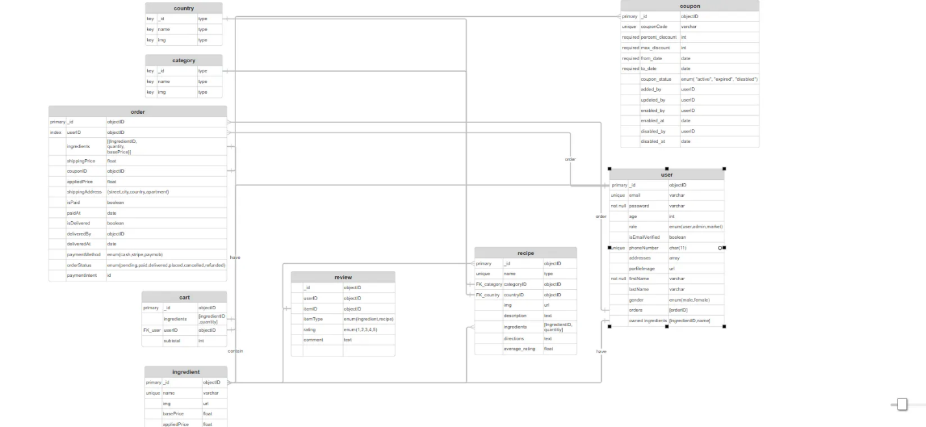

**Figure 3.1**

The **tables** form a clear and organized structure for managing users, recipes, ingredients, and chatbot interactions. This design ensures smooth data flow, supports personalized features, and allows the system to scale efficiently.

**1. user Table**

**Represents application users.**

* **Key fields:** userID, email, fullName, gender, location, savedIngredients
* **Relationships:**
* One-to-many with order (a user can place multiple orders)
* One-to-many with review (a user can leave reviews for multiple recipes)
* Stores a list of saved ingredients (for personalized suggestions)

**2. Recipe Table**

**Stores recipe data.**

* **Key fields**: recipeID, title, description, ingredients, steps, image_url
* **Relationships**:
  + Many-to-one with category (each recipe belongs to a category)
  + Many-to-one with country (each recipe can belong to a country)
  + One-to-many with review (recipes can have multiple user reviews)

**3. Ingredient Table**

**Contains all the available ingredients used in recipes and shopping.**

* **Key fields**: ingredientID, name, unit, type
* **Relationships**: Linked to cart and order (ingredients are part of a cart or placed order)

**4. Cart Table**

**Represents the user's shopping cart.**

* **Key fields**: userID, ingredientID, quantity
* **Relationships**:
  + Many-to-one with user (a cart belongs to a user)
  + Many-to-one with ingredient (ingredients are stored in the cart)

**5. Order Table**

**Handles user orders and checkout.**

* **Key fields**: orderID, userID, ingredients, shippingAddress, paymentStatus, deliveryStatus
* **Relationships**:
  + Many-to-one with user (an order belongs to a user)
  + Contains multiple ingredients (structured as embedded or referenced data)

**6. Review Table**

**Manages user reviews for recipes.**

* **Key fields**: userID, recipeID, rating, comment
* **Relationships**:
  + Many-to-one with user (the user who gave the review)
  + Many-to-one with recipe (recipe that was reviewed)

**7. category Table**

**Defines recipe categories (e.g., Vegan, Desserts, Breakfast).**

* **Key fields**: categoryID, name
* **Relationships**:
  + One-to-many with recipe (a category can have many recipes)

**8. country Table**

**Defines origin or cuisine of the recipe.**

* **Key fields:** countryID, name
* **Relationships**:
  + One-to-many with recipe (a country can have many recipes)

**9. coupon Table**

**Manages discount codes available to users.**

* **Key fields:** couponCode, percent_discount, status, valid_from, valid_to
* **Relationships:**
  + Can be applied during the ordering process

**3.2.3 Choice of Design Methodologies: DFD & UML**

**Introduction:**

In our project, we are using a combination of **Data Flow Diagrams (DFD)** and **Unified Modeling Language (UML)** diagrams. This decision is based on the architectural differences between our **backend system (Node.js + React)** and our **mobile application (Flutter)**. Since these technologies follow different paradigms, selecting the appropriate modeling techniques ensures a structured and efficient design

**1. Why Use DFD for the Backend (Node.js + React)?**

The backend of our system is developed using **Node.js,** and the frontend web application is built with **React** following a **functional programming** paradigm.

**Key Reasons for Using DFD:**

* **Focus on Data Flow**: Since our backend is responsible for handling **requests, responses, and database operations**, a **data-centric** diagram like DFD is ideal.
* **Event-Driven Nature**: Node.js is **event-driven** rather than object-oriented. DFDs help in understanding how data moves **between different entities** (users, database, AI model, etc.)
* **No Need for Object Interactions**: Functional programming focuses on **pure functions and immutable data**, so using **Class Diagrams or Object-Oriented models** wouldn't provide much value.
* **Better Representation of API Workflows**: DFDs illustrate how **requests and responses** flow in the system, making them useful for backend API design

**Example of DFD Usage in Our System:**

* **User searches for a recipe** → Request flows from the frontend to the backend.
* **Backend fetches the relevant data** → either from the database (static search) or AI model (dynamic search).

**Response is sent back** → Displayed to the user in the frontend.

**2. Why Use UML for the Flutter App?**

Our mobile application is developed using Flutter, which follows an Object-Oriented Programming (OOP) paradigm.

**Key Reasons for Using UML:**

* OOP-Based Structure: Flutter applications are built using objects, classes, and state management. UML diagrams (such as Class Diagrams, Sequence Diagrams, and Activity Diagrams) are perfect for object-oriented designs.
* Clear Representation of Components: UML Class Diagrams allow us to define widgets, models, and controllers in a structured way.
* State and Behavior Modeling: Flutter apps often involve complex user interactions, navigation, and lifecycle management, which are best represented using State Diagrams and Activity Diagrams.
* Better Communication with Mobile Developers: Since mobile developers are used to OOP principles, UML diagrams make the app's design more intuitive.

**Example UML Usage in Our System:**

1. **Class Diagram** → Defines the structure of key components such as Recipe, User, Search Manager, etc.
2. **Activity Diagram** → Represents the search flow, including selecting filters, toggling between static and AI search, and displaying results.

**Conclusion: A Hybrid Approach**

By using DFD for the backend and UML for the mobile app, we are ensuring that our documentation aligns with the technical structure of each system.

| **Technology** | **Programming Paradigm** | **Design Methodology** |
| --- | --- | --- |
| **Node.js (Backend)** | Functional & Event-Driven | **DFD** |
| **React (Frontend)** | Functional Components | **DFD** |
| **Flutter (Mobile App)** | Object-Oriented | **UML** |

This approach provides clarity, maintainability, and scalability while keeping our design documentation relevant to our technology stack.

**3.2.4 UML Use Case Diagram:**

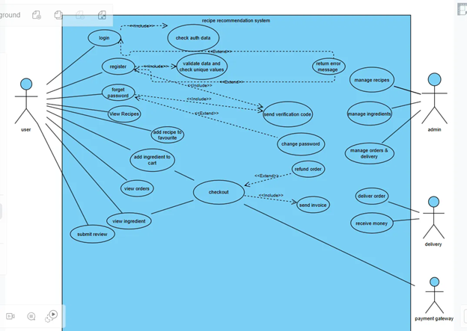  
 **Figure 3.2**

This diagram represents the various functionalities of the system and the actors involved.

**Actors:**

1. User: The primary system end-user.
2. Admin: Manages recipes, ingredients, orders, and deliveries.
3. Delivery: Handles orders.
4. Payment Gateway: Processes payments.

**Functionalities:**

**User Actions:**

* Login/Register: Validates and authenticates user credentials.
* Password Reset: Sends a verification code for password recovery.
* Browse Catalog: Views of recipes and ingredients.
* Favorite Recipes: Saves recipes for quick access.
* Shopping: Adds ingredients to cart, checks out, and views order history.
* Submit Reviews: Provides feedback on recipes.

**Admin Actions:**

* Manage Catalog: Creates, updates, or deletes recipes and ingredients.
* Order & Delivery Management: Oversees order processing and shipping.

**Delivery Actions:**

* Order Delivery: Ensures timely delivery to users.
* Payment Confirmation: Verifies payment receipt upon delivery.

**System Interactions:**

* Input Validation: Ensures accurate data during registration and checkout.
* Order Processing: Handles refunds and invoices.

**3.2.5 UML Activity diagrams:**

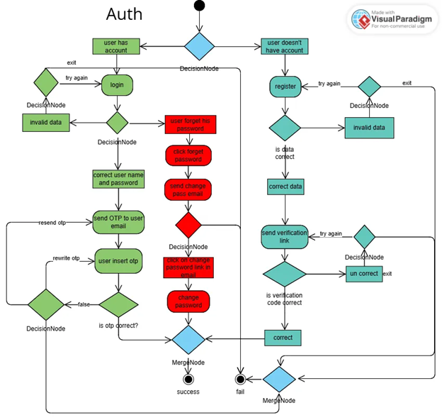  
 **Figure 3.3**

This diagram details the user authentication process, including login, registration, and password recovery.

**Login Process:**

1. User inputs account credentials.
2. If data is invalid, they are prompted to try again.
3. For valid credentials:

* OTP is sent to the registered email address.
* User enters OTP; if correct, login is successful.
* If incorrect, they are prompted to rewrite the OTP.

**Password Recovery Process:**

1. User clicks "Forgot Password."
2. A password reset email is sent.
3. Users click the link to reset their password.
4. If the link is correct, the user successfully changes the password.

**Registration Process:**

1. User inputs registration details.
2. Data is validated for correctness.
3. If valid:

* A verification link is sent to the email address.
* Users verify their account successfully.

1. If invalid or unverified, the user is prompted to retry.

**3.2.6 Buy ingredients diagrams:**

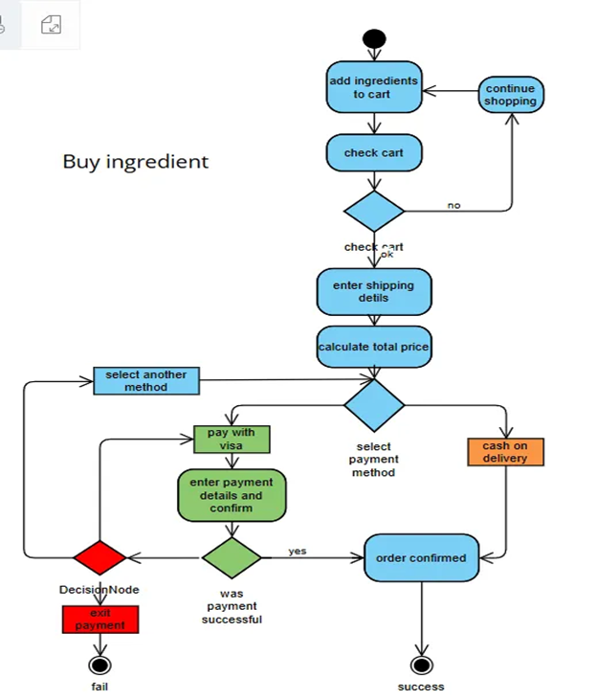

**Figure 3.4**

This diagram illustrates the process of purchasing ingredients.

**Process Flow:**

1. The user adds ingredients to the cart.
2. The user can:

* **Continue Shopping**: Return to browse more items.
* **Check Cart**: Proceed to checkout.

1. If the cart is valid:

* Shipping details are entered.
* Total price is calculated.

1. Payment Methods:The total
   * **Cash on Delivery**: Directly proceeds to order confirmation.
   * **Visa Payment**:
     + User enters payment details.
     + If payment is successful, the order is confirmed.
     + If payment fails, the user can retry or exit.
2. The order is marked as successful upon confirmation.

**3.2.7 Submit Review (Activity Diagram):**

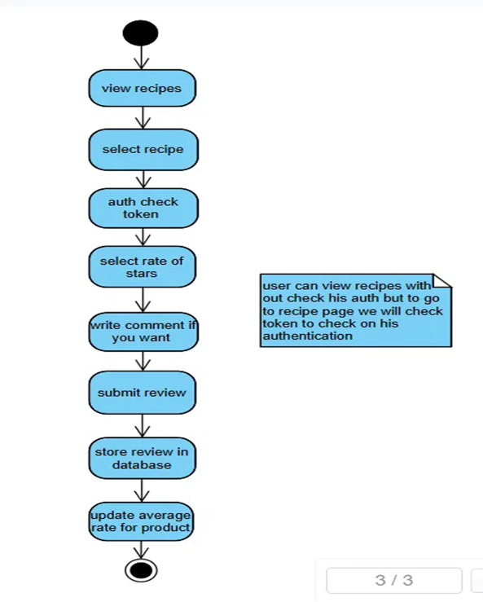  
 **Figure 3.5**

This activity diagram illustrates the process of submitting a review for a recipe in the system.

**Flow Explanation:**

1. **View Recipes:** The user browses through available recipes.
2. **Select Recipe:** The user selects one to review.
3. **Auth Check Token:** The system verifies user authentication via a token (authentication is required beyond viewing).
4. **Select Rate of Stars:** The user rates the recipe.
5. **Write a Comment (Optional):** The user may optionally add a comment.
6. **Submit Review:** The user submits their feedback.
7. **Store Review in Database:** The system saves the review data.
8. **Update Average Rate:** The recipe’s overall rating is recalculated based on the new review.

**3.2.8 Search (Static/AI) (Activity Diagram):**

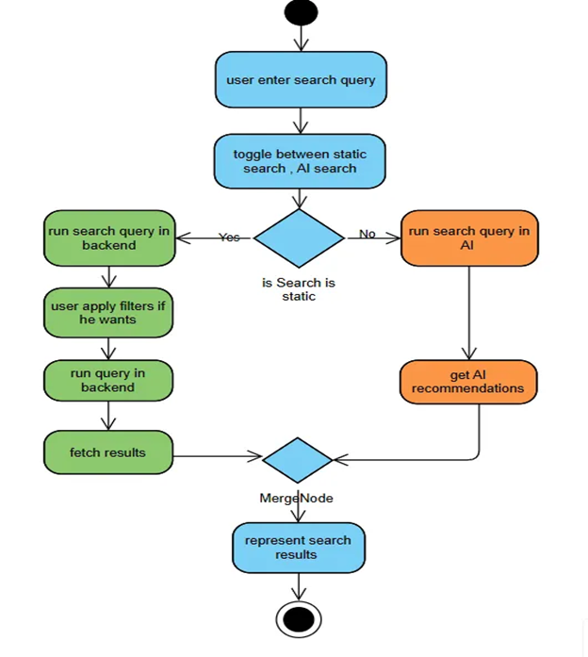

**Figure 3.6**

This diagram shows how the system processes a search query using either traditional (static) or AI-powered methods.

**Flow Explanation:**

1. **User enters search Query:** The user inputs a search term.
2. **Toggle Between Search Types:** User selects static or AI-based search.
3. **Decision – Static or AI?**
   * **If Static:**
     + The query runs in the back end.
     + Filters may be applied.
     + Final queries are executed and results are fetched.
   * **If AI:**
     + AI engine processes the query.
     + AI provides recommended results.
4. **Merge Node:** Results from either path are merged.
5. **Represent Search Results:** Results are shown to the user.

**Colors:**

* Blue: User actions
* Green: Static search process
* Orange: AI search process

**3.2.9 Login Sequence (Sequence Diagram):**

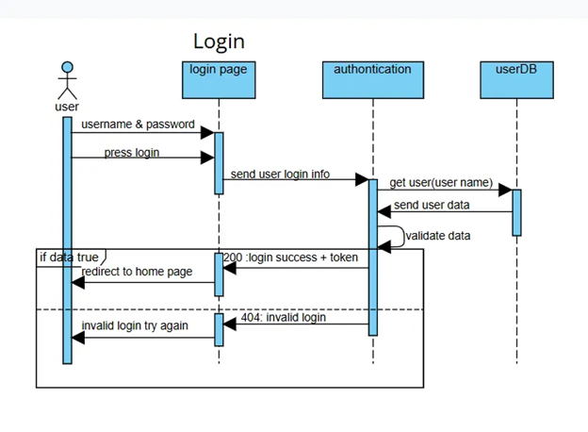  
 **Figure 3.7**

Illustrates the login process involving the user, front-end, authentication system, and user database.

**Flow Explanation:**

1. **User Inputs Credentials:** The Username and password are entered.
2. **Login Request Sent:** Frontend sends this to the authentication service.
3. **Authentication:** The Service retrieves user info from the database and validates credentials.

1. **If Valid:**
   * Authentication service returns a token.
   * Users are redirected to the homepage.
2. **If Invalid:**
   * Returns an error (e.g., 404 invalid login).
   * User prompted to try again.

**3.2.10 Register Sequence (Sequence Diagram):**

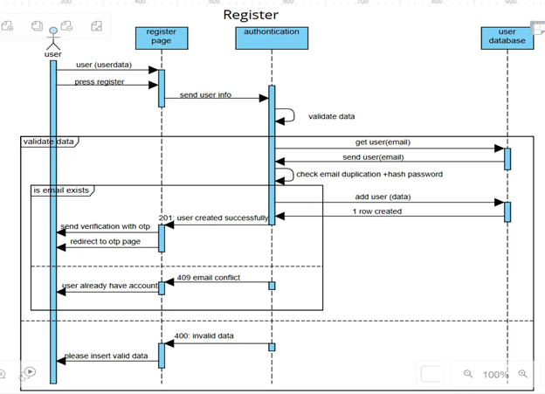  
 **Figure 3.8**

Demonstrates the flow of user registration, including validation, duplication check, and data storage.

**Flow Explanation:**

1. **User Enters Details:** Registration form is filled.
2. **Send to Authentication Service:** Data is sent for validation.
3. **Check Email Duplication:** Existing email check and password hashing.
4. **If Email Does Not Exist:**
   * New user data is stored in the database.
   * A successful response is returned.
   * User is redirected to an OTP page.
5. **If Email Exists or Invalid:**
   * Responds with 409 (email conflict) or 400 (invalid data).
   * Prompts user to try again.

**3.2.11 Purchasing ingredient Sequence (Sequence Diagram):**

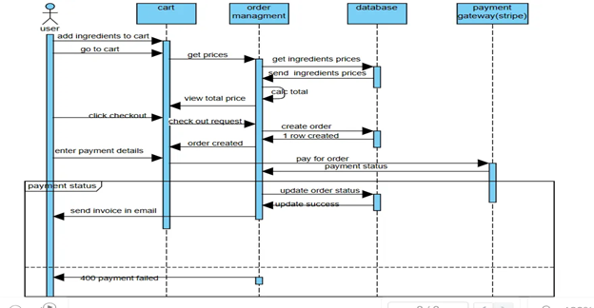  
 **Figure 3.9**

Explains the process of purchasing ingredients via the system.

**Flow Explanation:**

1. **Add to Cart:** User selects items and adds them to the cart.
2. **Checkout:** User proceeds to checkout and views the total price.
3. **Create Order:** The Backend creates an order in the database.
4. **Payment:** Payment details are entered into and processed using Stripe.
5. **Update Order Status:**
   * If payment is successful, the order status is updated, and an invoice is emailed.
   * If you fail, a 400 error is returned.

**3.2.12 Data Flow Diagram**

**A. Level 0 context diagram:**

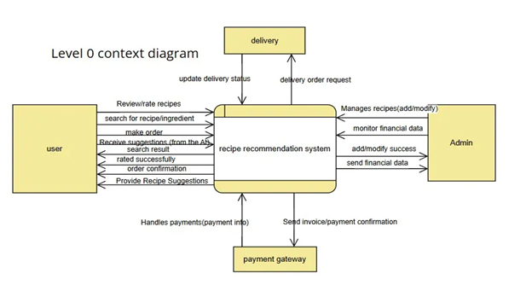  
 **Figure 3.10**

Provides a high-level overview of the system, showing how external entities interact with the main system (a black-box view).

**Components:**

* **External Entities:**
  + **User:** Initiates actions like registration, login, searching, submitting reviews, etc.
  + **Admin:** Manages backend tasks like moderation or updates.
* **Central Process:**
  + Represents the **Recipe System**, the main system where all interactions are processed.
* **Data Stores / Flows:**
  + Interactions include user data submission, recipe queries, review updates, login/logout handling, etc.
  + Data moves between users/admins and the system, which in turn communicates with the **Database** and **Authentication System**.

**Conclusion:**  
 The Level 0 diagram shows the entire system as a single process interacting with users, admins, and external components (like a database or auth service).

**B. Review and Favourites Module:**

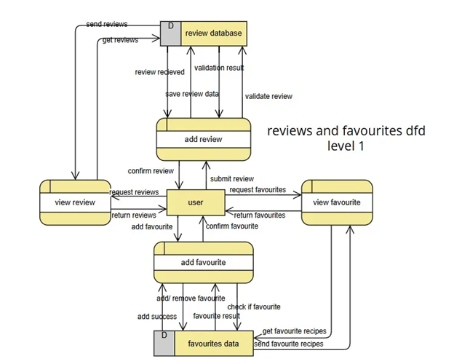  
 **Figure 3.11**

Breaks down the **Review and Favorites** module of the system to show internal processes and data flow.

**Processes & Flow:**

* **User Actions:**
  + Submit reviews, rate recipes, and favorite/unfavorite recipes.
* **Processes:**
  + Add review, calculate average rating, mark as favorite, retrieve reviews.
* **Data Stores:**
  + Review Data Store – stores submitted reviews and ratings.
  + Favorites Data Store – stores user-favorited recipes.
* **Outputs:**
  + Display average ratings, show list of favorite recipes, etc.

**Conclusion:**  
 This diagram shows how user input is processed, stored, and used to update and retrieve relevant data (like reviews or favorites).

**C. Authentication Subsystem**

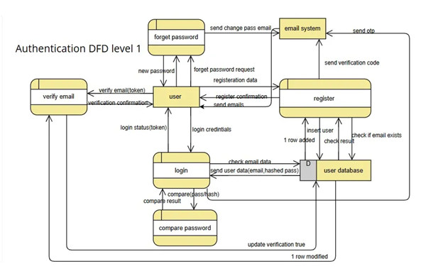  
 **Figure 3.12**

Details the **authentication subsystem**, describing how registration and login data flow through various internal modules.

**Processes & Flow:**

* **User Inputs:**
  + Registration data and login credentials.
* **Processes:**
  + Validate data, check for email duplication, hash passwords, and issue tokens.
* **Data Stores:**
  + User Database – holds user account data, including credentials and OTPs.
* **Outputs:**
  + Success/failure messages, tokens for login sessions, error responses.

**Conclusion:**  
 The authentication DFD gives a focused view of how users are verified and managed during login/registration, ensuring data integrity and secure access.

**D. Order Flow:**

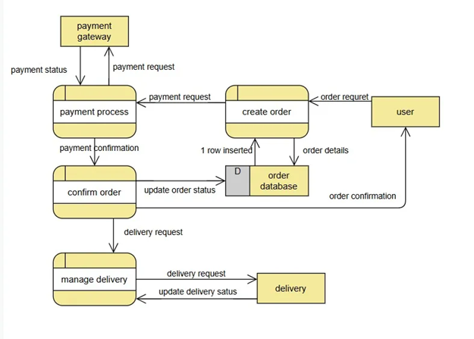  
 **Figure 3.13**

To show how a user's order moves through the system, from payment, order creation, and confirmation to delivery.

**Key Components & Flow:**

**1. User Interaction**

* **Input:**  
   The **user** initiates an **order request**.
* **Output:**  
   Receives **order confirmation** after payment and processing.

**2. Create Order Process**

* Receives the order request from the user.
* **Creates an order record** in the order database.
* Sends **order details** forward for processing and confirmation.

**3. Payment Process**

* Communicate with the **payment gateway**.
* **Sends a payment request**, receives **payment status** (success/failure).
* Send **payment confirmation** to the confirm order process if successful.

**4. Confirm Order**

* Verifies payment confirmation.
* **Updates the order status** in the order database.
* Send an **order confirmation** to the user.

**5. Manage Delivery**

* Once an order is confirmed, it sends a **delivery request**.
* Communicates with the **delivery system** and updates the **delivery status** in the order database.

**Data Stores**

* **OrderDatabase(D):**  
  Central storage where all order data, statuses, and delivery details are updated and retrieved.

**External Entities**

* **User** – initiates and receives order confirmation.
* **Payment Gateway** – handles secure payment transactions.
* **Delivery System** – manages the delivery of the order to the user.

**Summary**

This diagram outlines the backend flow of a typical **e-commerce order**: from user initiation, secure payment processing, order confirmation, and finally delivery managemental while consistently updating a centralized order database.

**3.3.1 Algorithms or Frameworks Used**

To deliver a smart, responsive, and user-friendly experience, the development of Reciplore relied on a combination of intelligent algorithms and powerful development frameworks. These components were carefully selected and implemented to ensure scalability, speed, accuracy, and ease of use.

**1. Algorithms:**

**Recipe Recommendation Algorithm:**

* Based on user mood, preferences, dietary restrictions, and available ingredients, the system ranks and filters recipes to offer the most suitable options.

**2. Frameworks and Tools:**

**Flutter:**

* Used to build the cross-platform mobile frontend, supporting Android and iOS. Key advantages include:
  + Unified and consistent UI.
  + Fast development with hot reload.
  + Rich UI components for interactive user experiences.

**React.js:**

* Used for developing the web-based interface. It provides:
  + Modular, component-based architecture.
  + Fast rendering via the Virtual DOM.
  + Responsive and dynamic interface design.

**Node.js**

* Handles the backend logic, including:
  + Serving API endpoints for frontend interaction.
  + Managing requests to and from the AI model.
  + Handling recipe-related data processing.

**Firebase (App Distribution only)**

* Used exclusively for application distribution, not authentication or data storage. It helps:
  + Distribute the mobile app to testers.
  + Manage builds and testing versions easily before release.

**TensorFlow / Pre-trained AI Model**

* Integrated as the AI engine behind the system. Responsibilities include:
  + Interpreting user-provided ingredients and preferences.
  + Generating relevant recipe recommendations.
  + Supporting natural interaction in the chatbot feature.

Chapter 4

Implementation

This chapter details the implementation of the recipe recommendation system, covering the technologies, tools, and programming languages used, the key components and modules, the database schemas, and the challenges faced during development, along with their resolutions. The system is deployed with the frontend hosted on Vercel at <https://reciplore-frontend.vercel.app/> and the backend on Vercel at [https://graduation-project-ev6n.vercel.app/,](https://graduation-project-ev6n.vercel.app/) and our Flutter App is hosted on Firebase at the [Firebase App Testing Distribution Link](https://appdistribution.firebase.google.com/testerapps/1:833514715472:android:3fc9ba03ddfe9d9d2f9455/releases/4u4irgia8vtkg?utm_source=firebase-console)

**4.1 Technologies, Tools, and Programming Languages Used**

The recipe recommendation system was built using a modern tech stack to ensure scalability, performance, and a seamless user experience across web and mobile platforms. Below is a comprehensive list of technologies, tools, and programming languages employed.

**Frontend (React)**

* **React.js**: JavaScript library for dynamic, component-based web interfaces, hosted at <https://reciplore-frontend.vercel.app/>.
* **JavaScript (ES6+)**: Core language for frontend logic and interactivity.
* **HTML5 and CSS3**: Structure and styling, with Tailwind CSS for responsive design.
* **Axios**: Promise-based HTTP client for API requests.
* **React Router**: Client-side routing for navigation.
* **Vite**: Fast build tool for development and production.
* **Node.js and npm**: Runtime and package management.
* **Git and GitHub**: Version control, repository at <https://github.com/yous0001/Reciplore-frontend>.
* **Vercel**: A Deployment platform for the frontend.
* **Web Video Demo**: [Demo](https://drive.google.com/file/d/1317W6NmMnEelMnFieITmOxBfPsOvY4lC/view?usp=drivesdk)

**Mobile (Flutter)**

* **Flutter**: Cross-platform UI toolkit for iOS and Android apps, using the main branch at <https://github.com/A7mednage71/Reciplore.git>.
* **App Distributed**:[Firebase App Testing Distribution Link](https://appdistribution.firebase.google.com/testerapps/1:833514715472:android:3fc9ba03ddfe9d9d2f9455/releases/4u4irgia8vtkg?utm_source=firebase-console)
* **Dart**: A Programming language for Flutter UI and logic.
* **Flutter Bloc**: State management library.
* **HTTP Package**: API requests from the mobile app.
* **Git and GitHub**: Version control for the mobile codebase.
* **App Video Demo**:
  + [Home features Demo](https://www.loom.com/share/752e58a712c2429d890c2299068115a4?sid=6d2043e6-51ec-4d87-8635-0d8ed692516c)
  + [AI Features Demo](https://www.loom.com/share/62a82182581b44aebc4132b1cce67231?sid=f6c50e9a-4211-4949-be24-b89ae8610f21)
  + [Market and Payment Demo](https://www.loom.com/share/af5dc832333d4871a2d387cc281a98e6?sid=8f982979-4fb5-424e-91e4-784451c1dfb0)

**Backend (Express.js)**

* **Express.js**: Node.js framework for RESTful APIs, hosted at <https://graduation-project-ev6n.vercel.app/>.
* **Node.js**: Server-side JavaScript runtime.
* **MongoDB**: NoSQL database via MongoDB Atlas.
* **Mongoose**: Object Data Modeling (ODM) for MongoDB.
* **JSON Web Tokens (JWT)**: Secure user authentication.
* **Axios**: Communication with the Flask AI server.
* **CORS**: Cross-origin request support.
* **Nodemon**: Auto-restart for development.
* **Git and GitHub**: Version control, repository at <https://github.com/yous0001/Graduation-Project>.
* **Vercel**: Backend deployment platform.

**AI Model (Flask Server)**

* **Flask**: Python framework for the AI recommendation server.
* **Python 3**: Language for the AI model and the Flask server.
* **Pandas and NumPy**: Data manipulation and computations.
* **NLTK and SpaCy**: NLP for text preprocessing.
* **Scikit-learn**: TfidfVectorizer and cosine_similarity for recommendations.
* **Pickle**: Model serialization.
* **Gunicorn**: WSGI server for Flask deployment.
* **Heroku**: Flask server hosting.
* **Git and GitHub**: Version control, integrated into the backend repository.

**Development Tools**

* **Visual Studio Code**: Primary IDE.
* **Postman**: API testing.
* **Docker**: Containerization for backend and Flask server.
* **MongoDB Compass**: MongoDB management GUI.
* **GitHub Actions**: CI/CD automation.

**4.2 Key Components/Modules of the System**

The system comprises four layers: frontend (React), mobile app (Flutter), backend (Express.js), and AI model (Flask server). Below is a detailed list of components and modules, with explanations to support accompanying images. Database schemas are described to align with the code images provided.

**Frontend (React) Components**

The frontend, hosted at <https://reciplore-frontend.vercel.app/>, includes:

* **HomePage**
  + **Description**: Landing page with featured recipes, a search bar, and dietary filters, styled with Tailwind CSS.
  + **Functionality**: Fetches trending recipes via Axios and enables navigation to search or profile sections.

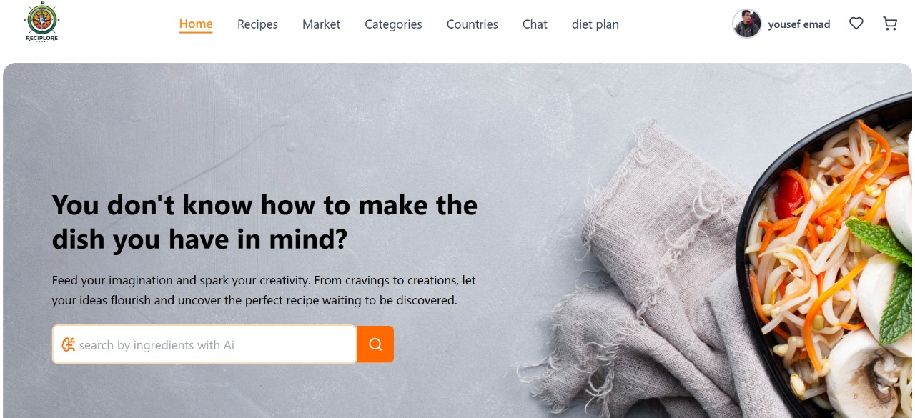

**Figure 4.1**

* **RecipeSearch**
  + **Description**: Search interface for recipes by ingredients or preferences, with input fields and dropdowns.
  + **Functionality**: Sends queries to the backend, displaying results in a responsive grid.

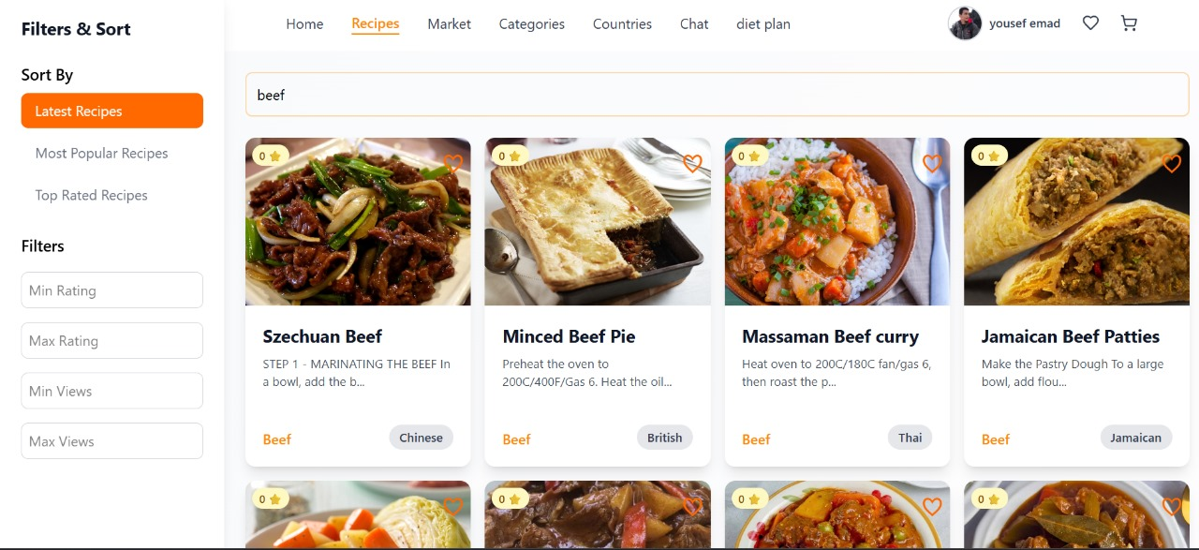

**Figure 4.2**

* **RecipeDetails**
  + **Description**: Displays recipe details (ingredients, instructions, nutrition) in a clean layout.
  + 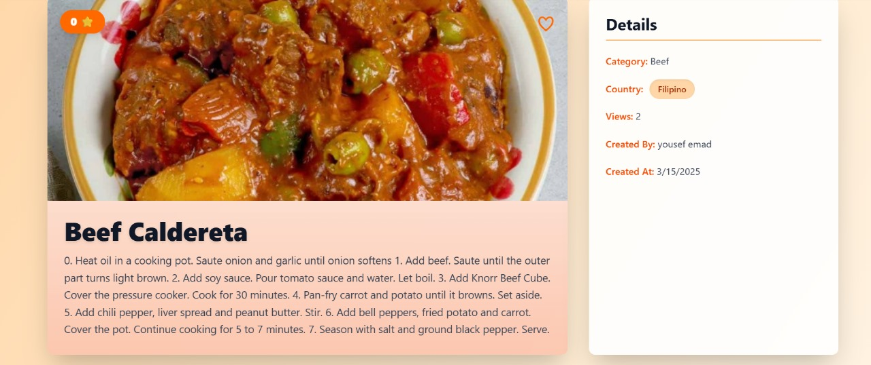**Functionality**: Fetches data via API and supports saving recipes or adding ingredients to pantry.

**Figure 4.3**

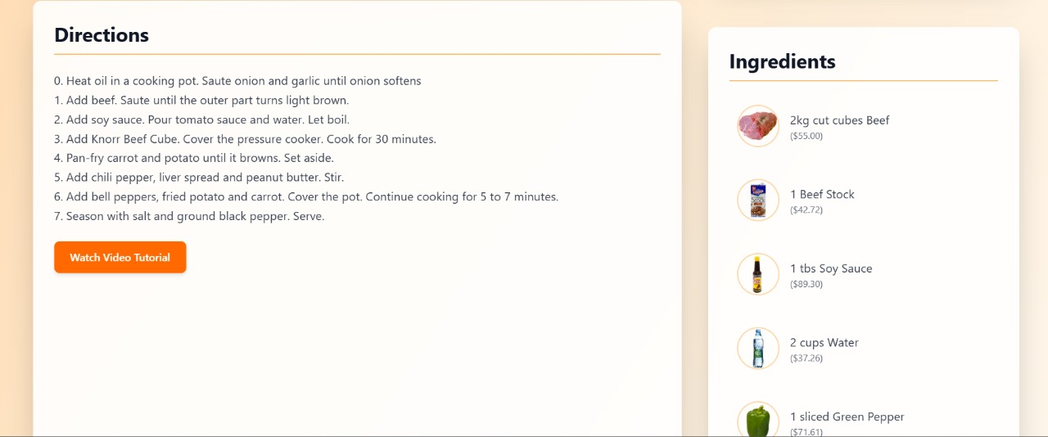

* **UserProfile**
  + **Description**: Manages user preferences, saved recipes, and pantry, styled with Tailwind CSS.
  + **Functionality**: Performs CRUD operations via backend APIs, secured with JWT.

**Figure 4.4**

* **AuthComponents (Login/Signup)**
  + **Description**: Authentication forms styled with Tailwind CSS.

**Functionality**: Uses JWT for secure login/signup, storing tokens in cookies

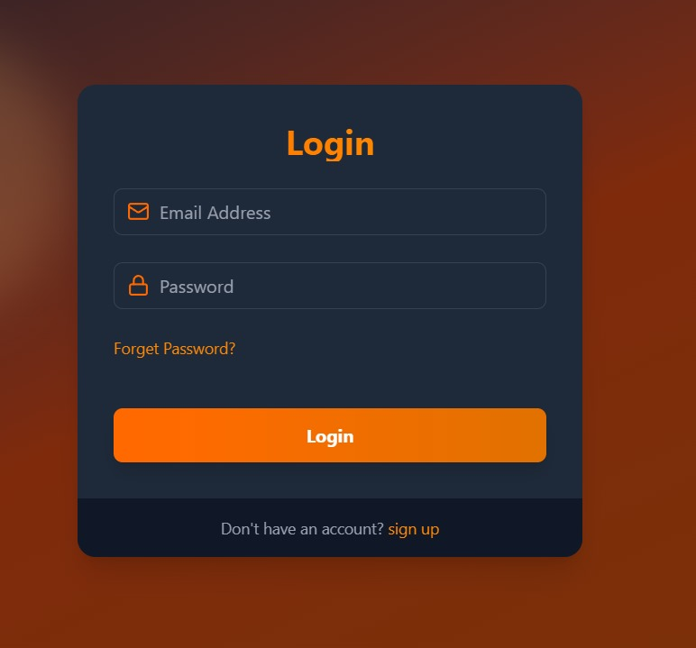

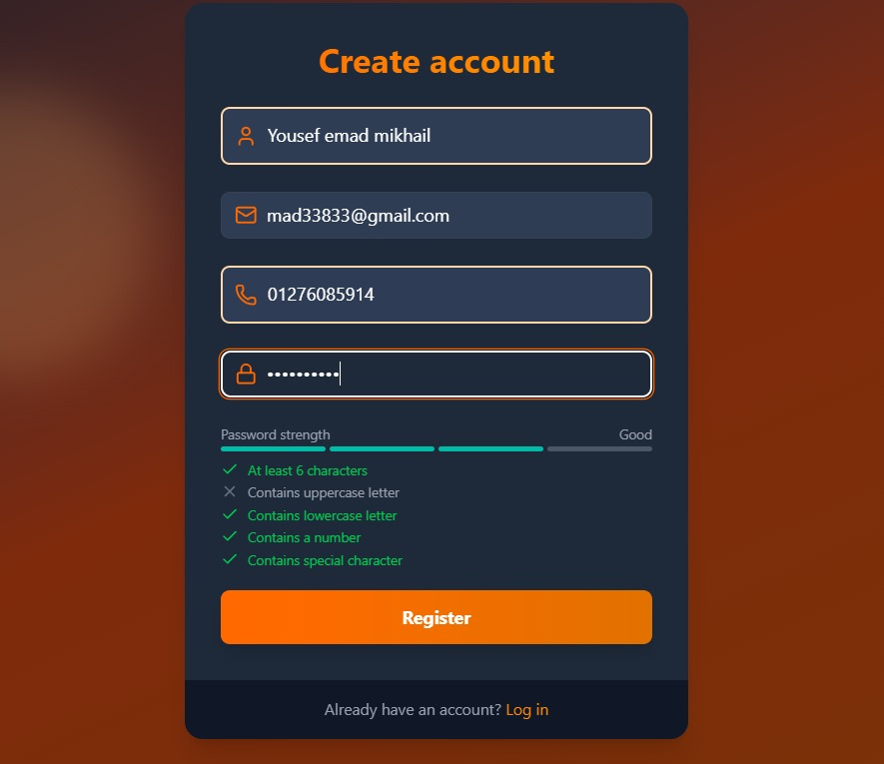

**Figure 4.5**

**Figure 4.6**

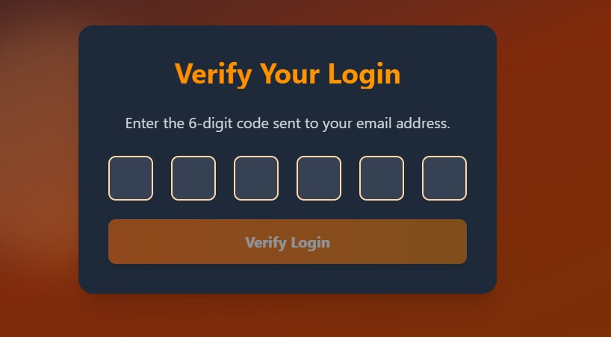

* **PantryManager**
  + **Description**: Interface for managing pantry ingredients.
  + 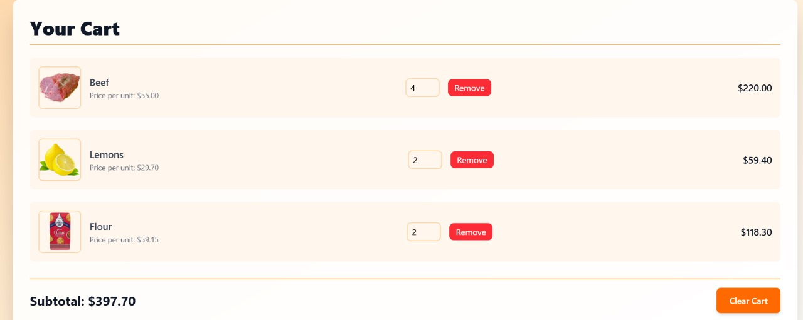**Functionality**: Syncs with backend MongoDB for recommendation inputs.

**Figure 4.7**

**NavigationBar**

* + **Description**: Responsive navigation using React Router and Tailwind CSS.
  + **Functionality**: Enables seamless page transitions.



* **Categories of Recipes**
  + **Description**: Displays recipes categories in a grid.
  + 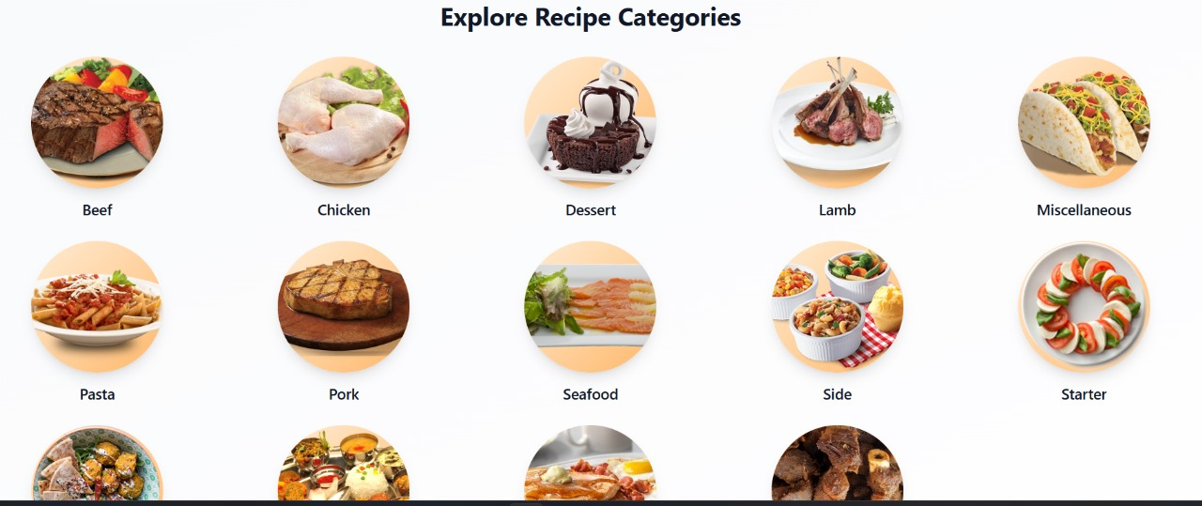**Functionality**: Fetches and manages c**ategories** ofrecipes via API.

**Figure 4.8**

* **Diet plan**
  + **Description**: Make a diet plan personalized for you
  + 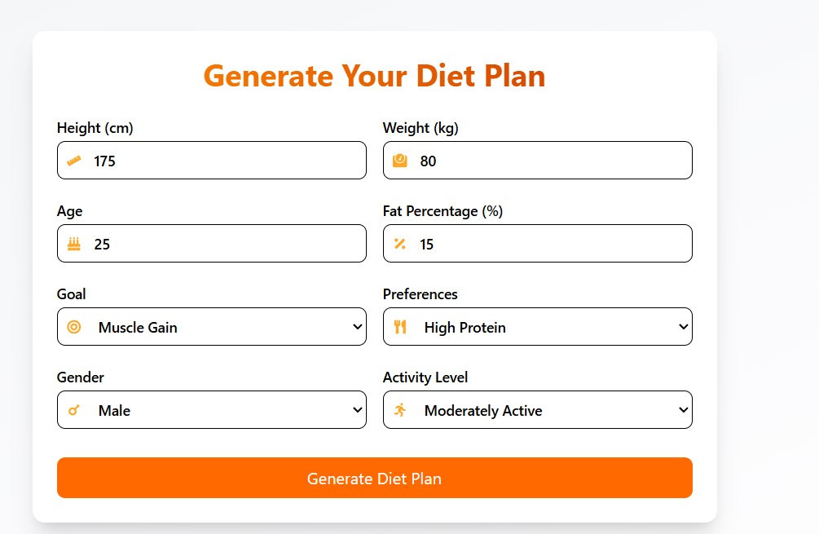**Functionality**: make a diet plan for 30 days each day containing breakfast, lunch, dinner, 2 snacks each meal with ingredients and directions to make it
* **Chatbot** 
  + **Description**: Recommend recipes based on ingredients and mood
  + **Functionality**: recommend recipes based on ingredients and chat based on our AI agent, which contains models of Gemini,huggingface,…..

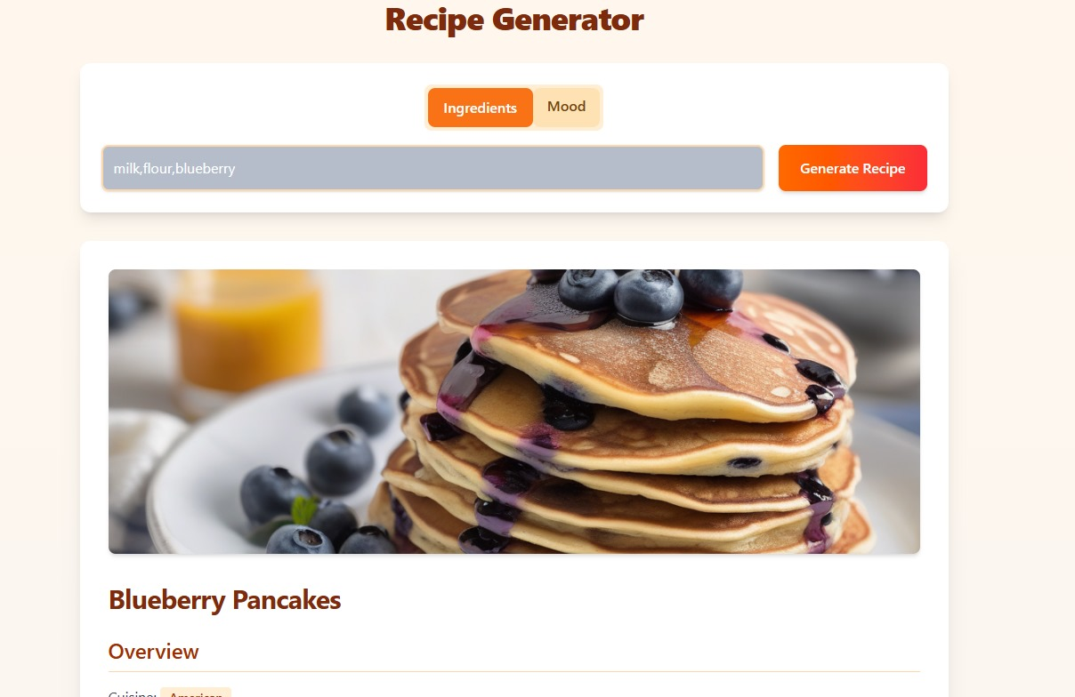

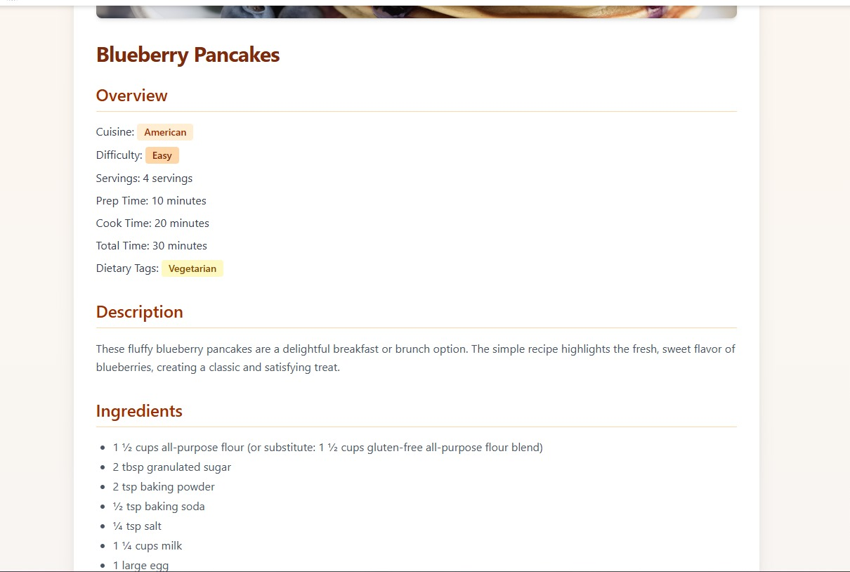

**Figure 4.9**

**Mobile App (Flutter) Components:**

The mobile app, using the main branch at <https://github.com/A7mednage71/Reciplore.git>, includes:

* **Onboarding Screen Figure 4.10**

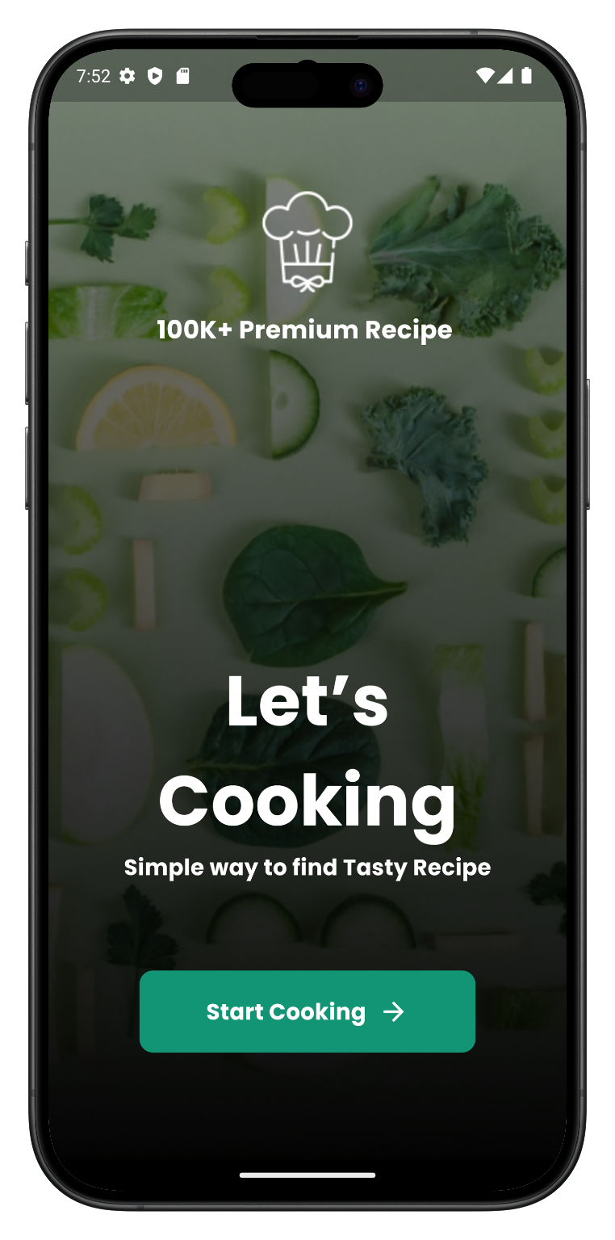

* **HomeScreen**
  + **Description**: Main screen with recommended recipes and search, using Material Design.
  + **Functionality**: Uses Bloc for dynamic recipe lists via HTTP requests

**Figure 4.11**

* + 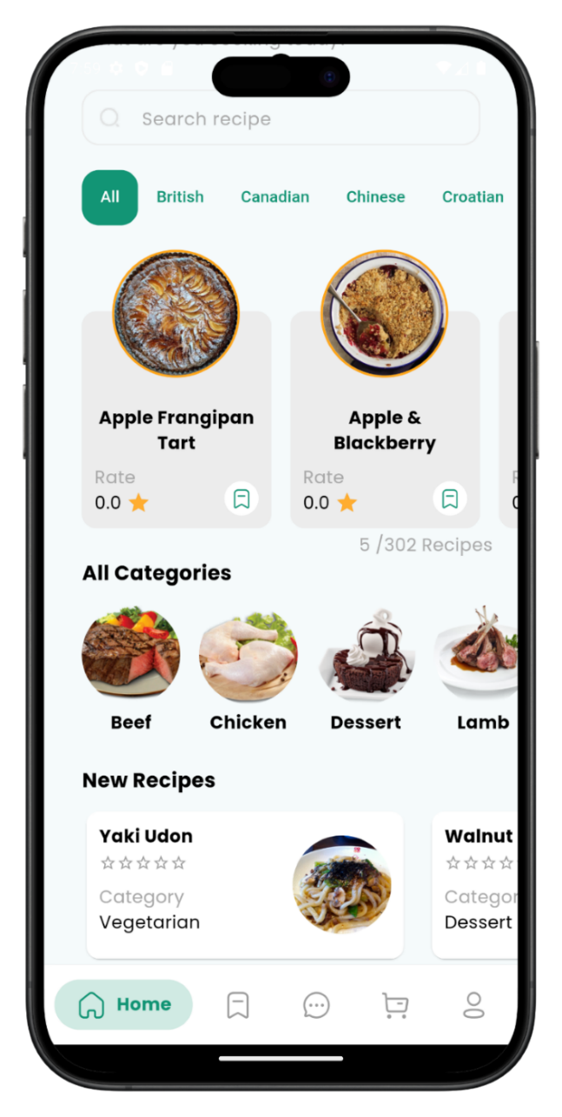
* **RecipeSearchScreen**
  + **Description**: Mobile search interface for recipes.
  + **Functionality**: Sends queries to the backend, displays results with Bloc.
* **RecipeDetailScreen**
  + **Description**: Shows recipe details optimized for mobile.
  + **Functionality**: Fetches data and supports saving/sharing recipes. **(Figure 4.12)**

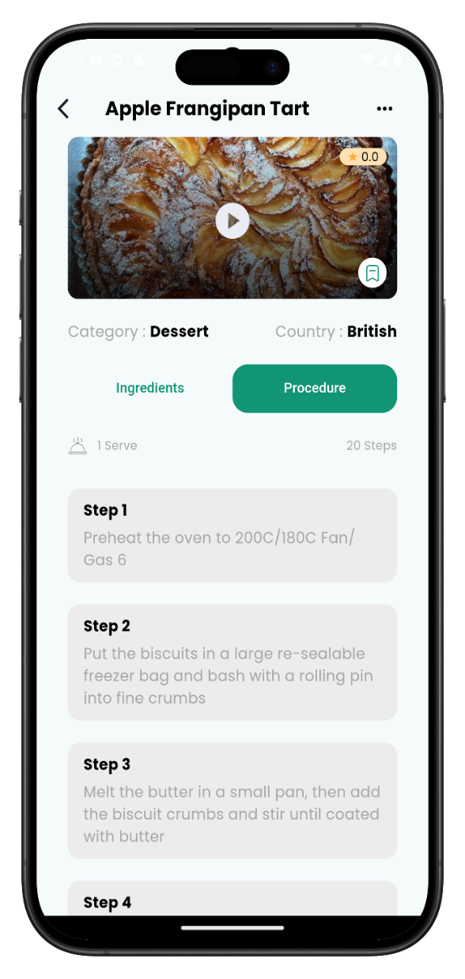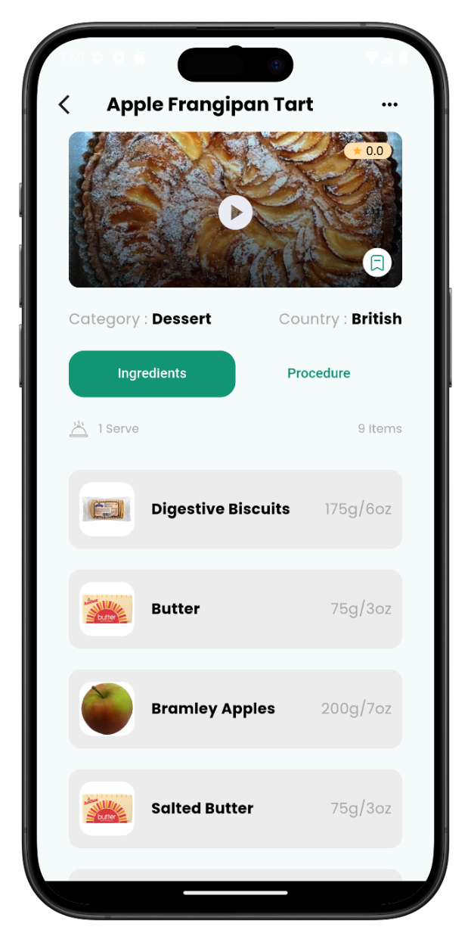

|  |  |
| --- | --- |
| **Reviews Screen Figure 4.13**  Here, Users can ***review recipes***, sharing the best and worst ***outcomes*** to offer quality insights, helping others make informed choices with trusted ***feedback***. |  |

* **Profile screen**

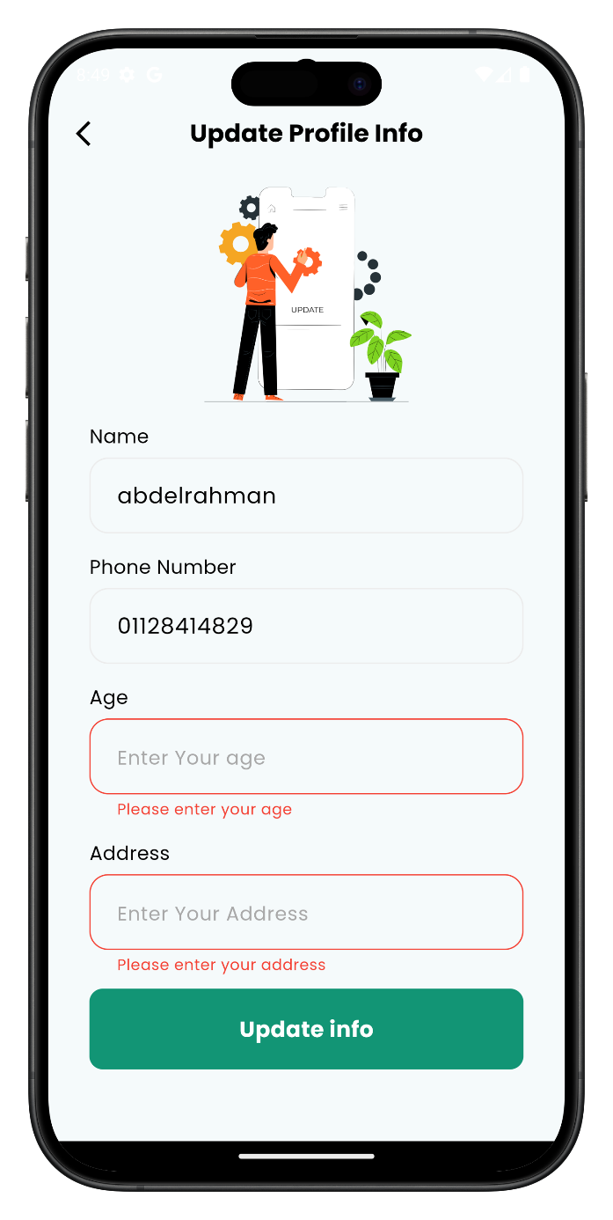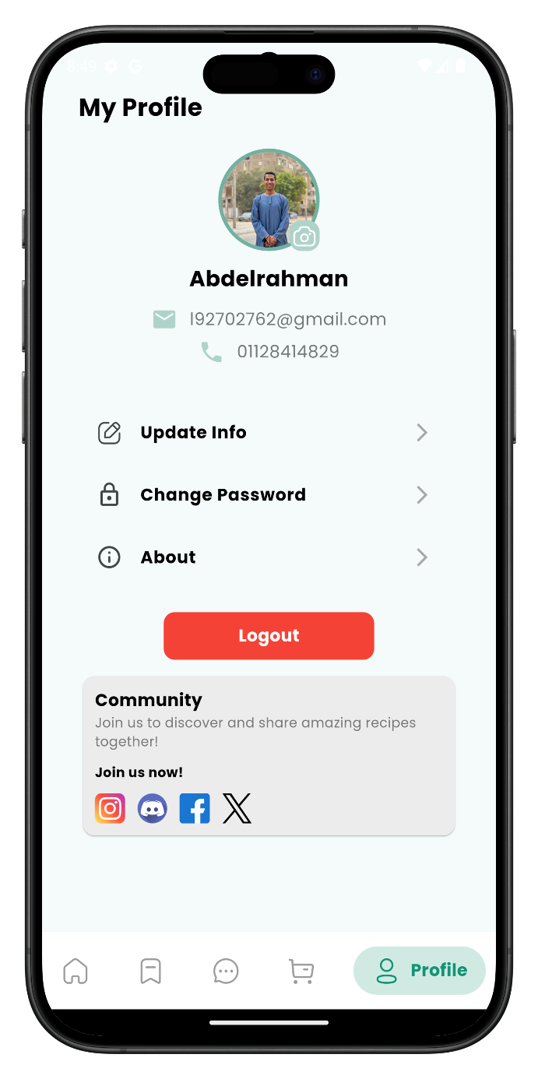

Users can update their photo, email, phone, or password, as well as log out or explore the app’s community from this screen. **(Figure 4.14)**

* **PantryScreen**
  + **Description**: Manages pantry ingredients in a list UI.
  + **Functionality**: Syncs with MongoDB for recommendations.
* **AuthScreens (Login/Signup)**
  + **Description**: Mobile authentication forms.
  + **Functionality**: Integrates with backend JWT authentication.

**Figure 4.15**

* + 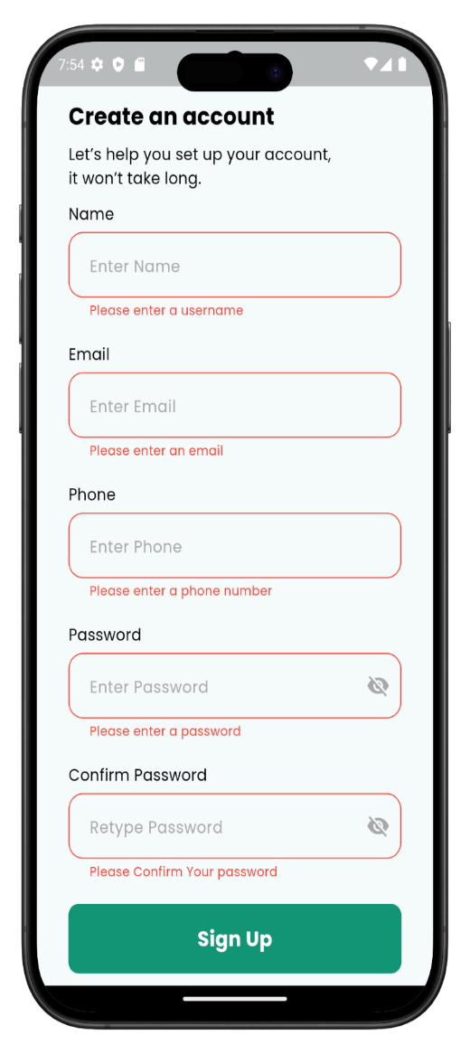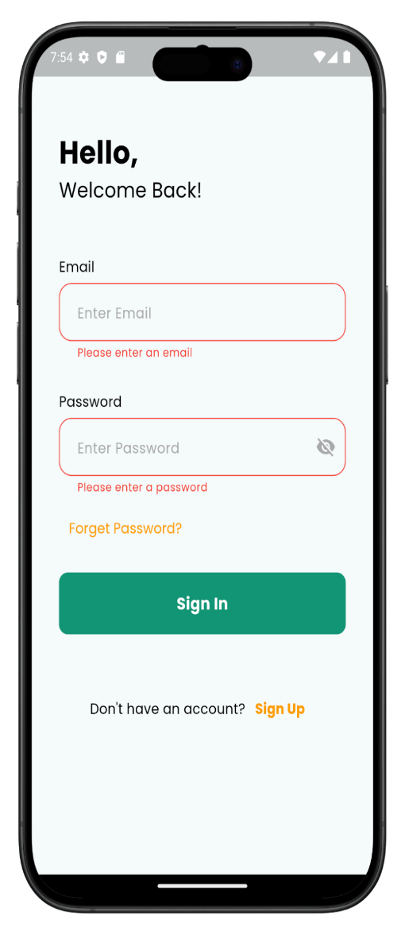
* **SavedRecipesScreen**
  + **Description**: Lists favorited recipes with swipe gestures.
  + **Functionality**: Manages saved recipes via API.

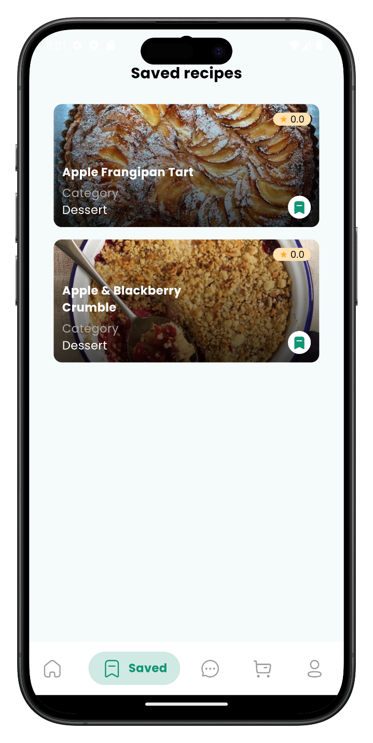 Figure 4.16

* **Chatbot AI**
  + **Description**: Chat bot helps you to make decisions.
  + **Functionality**: Send ingredients in chat, and it gives you a recipe.

|  |  |
| --- | --- |
|  |  |

**-** When you enter your ***ingredients***, it responds with a recipe’s ***title***, ***image***, additional ingredients (if needed), and ***preparation steps.* Figure 4.17**

**11. Market**

|  |  |
| --- | --- |
| * At the top of the screen, there is a cart icon/button that takes the user to the **Cart Page** when tapped. * **Search** bar with filter options * A **slider section** showcases current **discounts, promotions, and a cover banner**, helping users quickly spot the best deals. * The main section displays a **scrollable list of available products**, including fresh vegetables and other items available for sale | **Figure 4.18** |

* **Cart screen**
  + **Description**: Show the products that you added to the cart.
  + **Functionality**: Send ingredients in the cart to checkout.

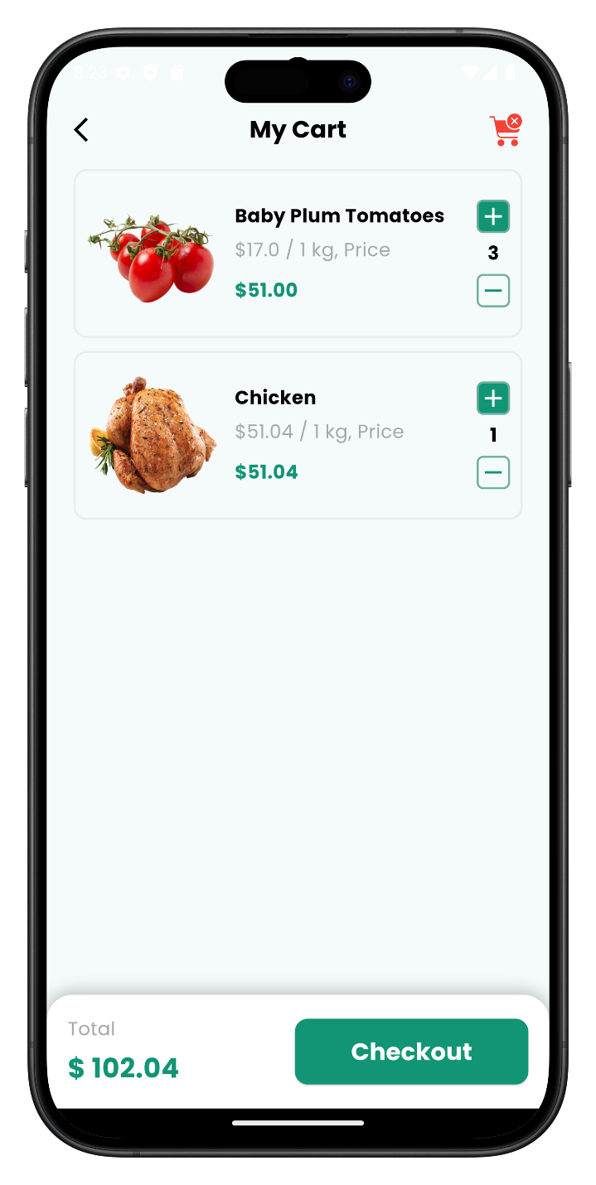

**Figure 4.19**

**• Ingredient Details Screen**

* Description: Shows detailed info about a selected ingredient.
* Functionality: Let the user mark it as available or add it to the shopping list.

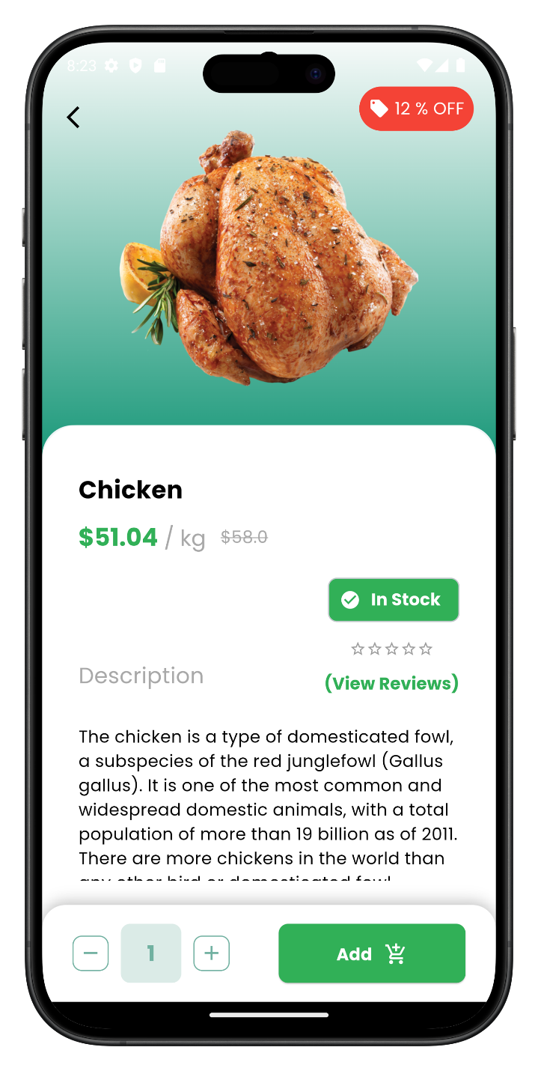**figure 4.20**

**Backend (Express.js) Modules**

The backend, hosted at <https://graduation-project-ev6n.vercel.app/>, includes the following modules, with database schemas described below:

* **UserController**
  + **Description**: Manages user operations (registration, login, profile updates).
  + **Functionality**: Interacts with the User schema in MongoDB, using JWT.

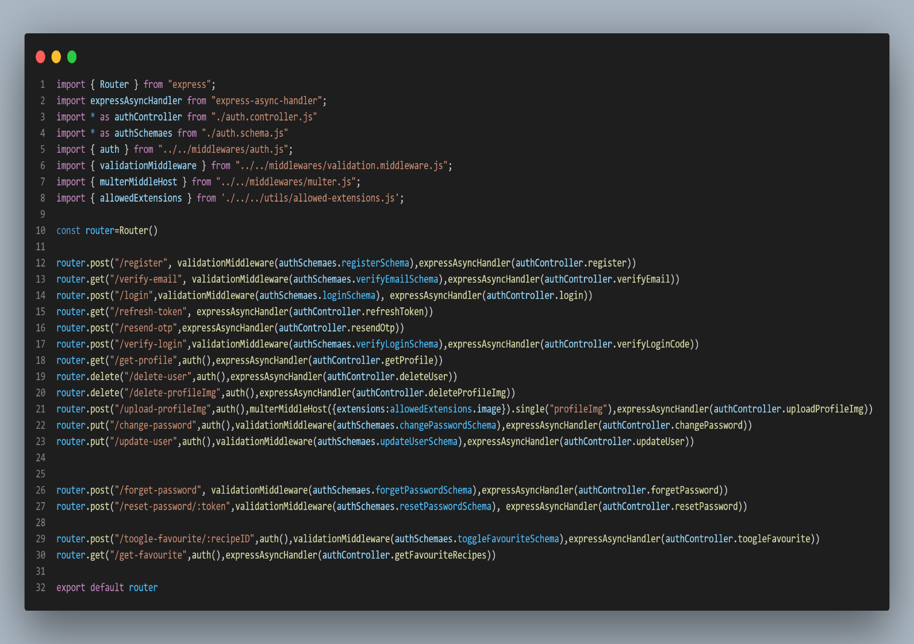

**Figure 4.21**

* **RecipeController**
  + **Description**: Handles recipe operations (fetching, searching).
  + **Functionality**: Queries the Recipe schema and communicates with the Flask server.

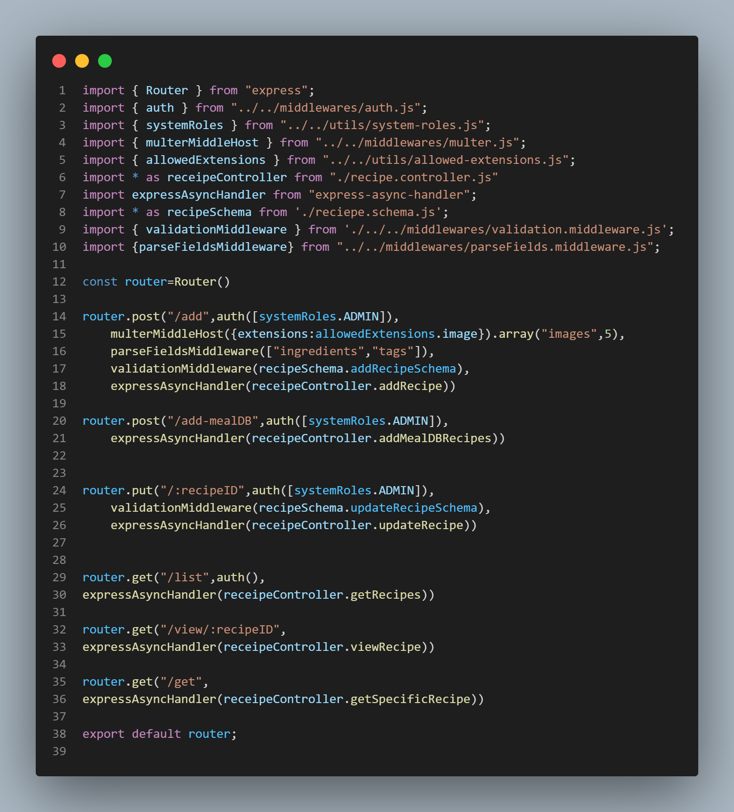

**Figure 4.22**

* **PantryController**
  + **Description**: Manages pantry data.
  + 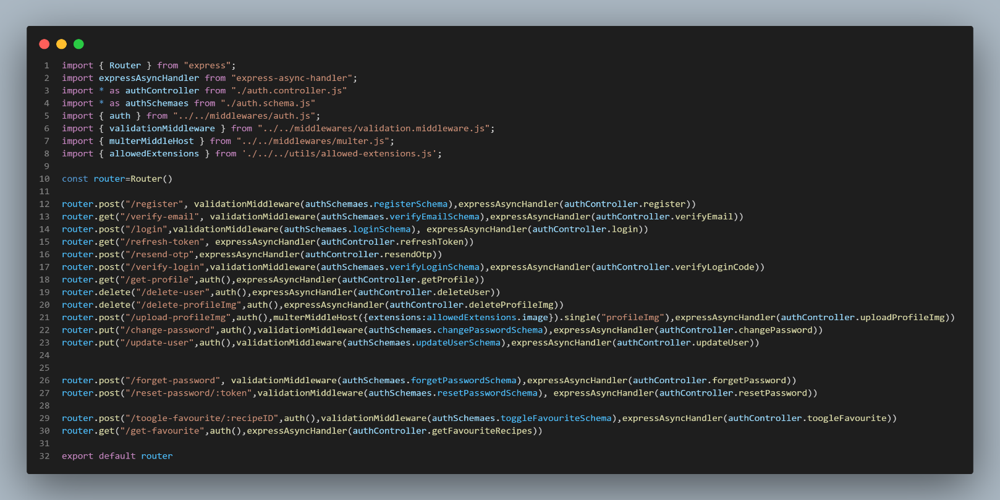**Functionality**: Updates the Pantry schema in MongoDB for recommendations

**Figure 4.23**

* **AIApiBridge**
  + **Description**: Bridges Express.js and Flask server.
  + 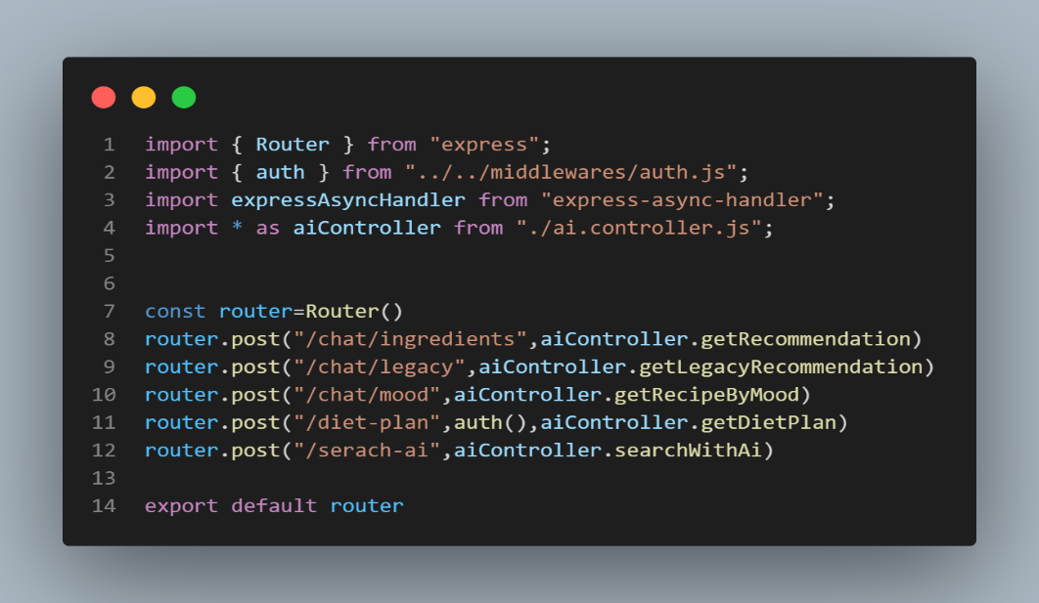**Functionality**: Sends user inputs to Flask via Axios, receives recommendations. **Figure 4.24**
* **API Route, middleware connection(index)**
  + **Description**: Defines RESTful API endpoints.
  + 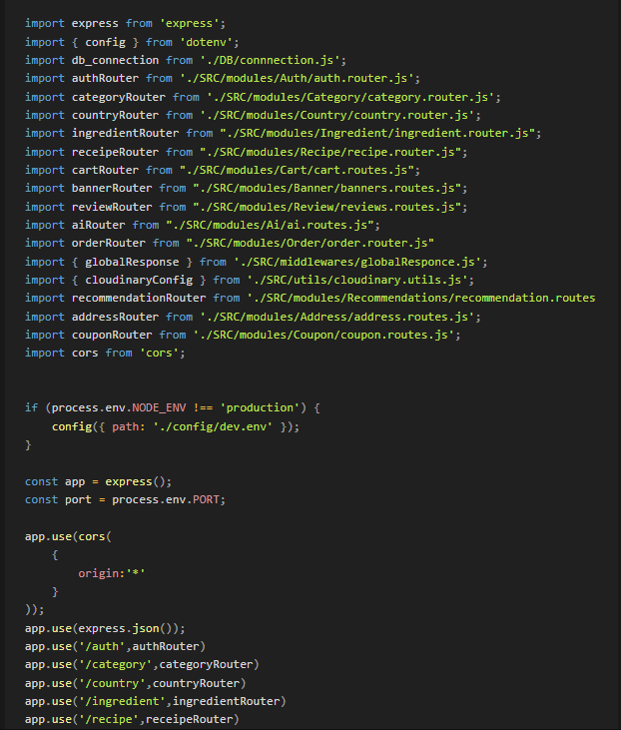**Functionality**: Handles requests with CORS support. (**Figure 4.25)**

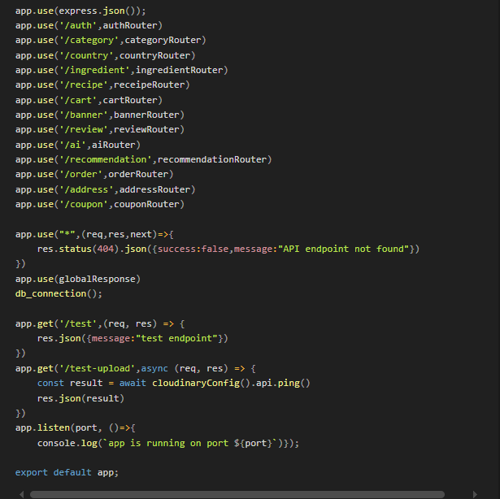

* **DatabaseConfig**
  + **Description**: Configures MongoDB connection.
  + **Functionality**: Manages Mongoose connection and schemas.

**Figure 4.25**

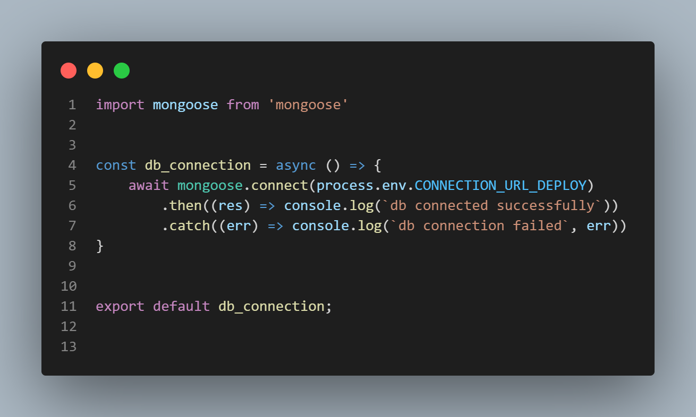

* **AuthMiddleware**
  + **Description**: Secures API endpoints.
  + **Functionality**: Validates JWT tokens.

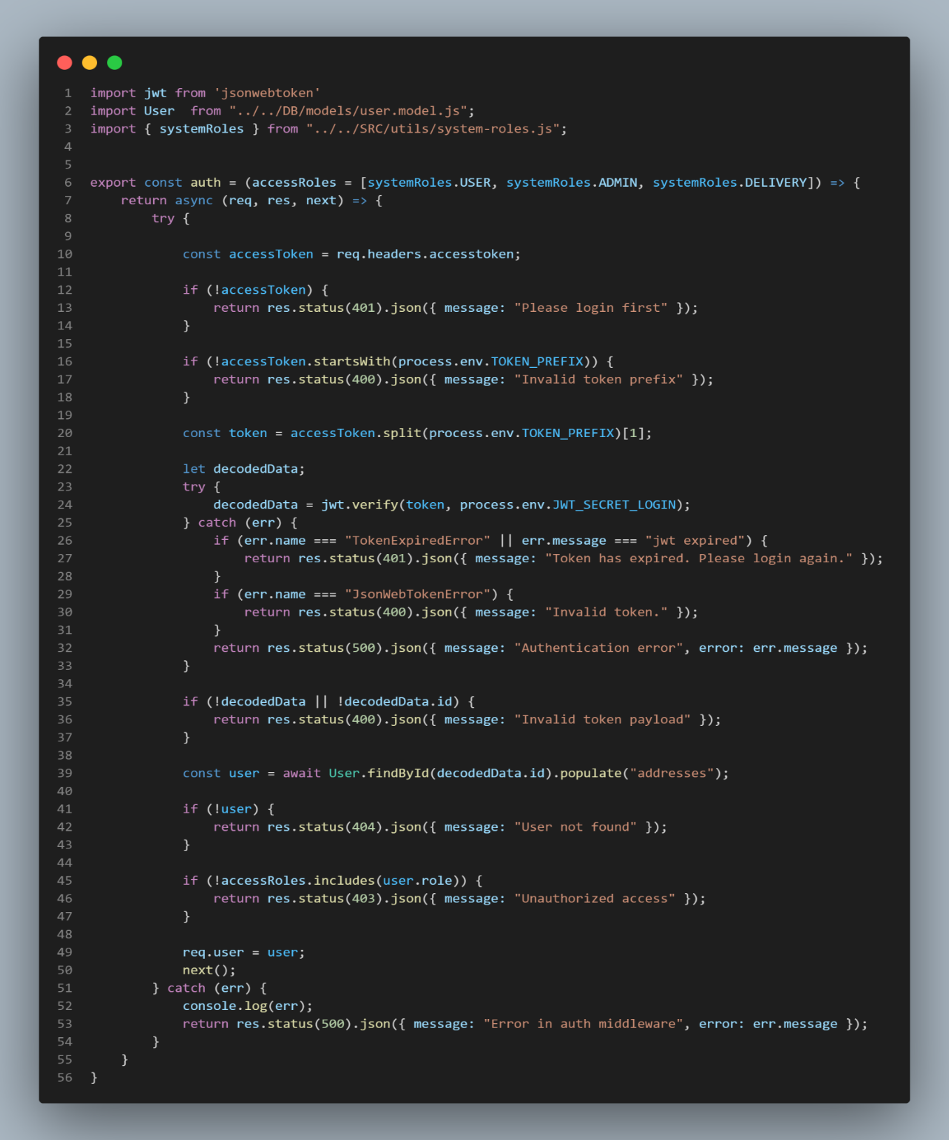 **Figure 4.26**

* **ErrorHandler**
  + **Description**: Centralized error handling.
  + **Functionality**: Logs errors and returns user-friendly responses.

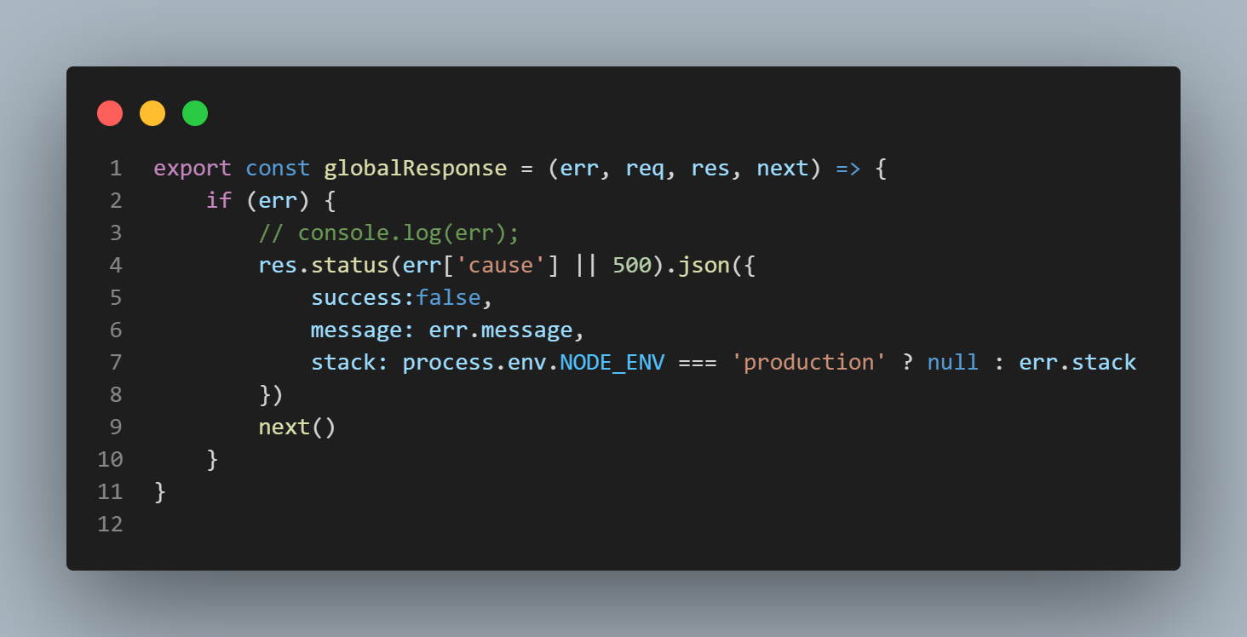

**Figure 4.27**

**Database Schemas**

The backend uses MongoDB with Mongoose to define schemas for storing data. Below are the descriptions for the User, Recipe, and Pantry schemas, typically defined in files like models/User.js, models/Recipe.js, and models/Pantry.js in the backend repository. These explanations support the code images provided.

**User Schema**

* **Description**: Defines the structure for user data, including authentication and profile information. It stores user credentials, preferences, and references to saved recipes and pantry items.
* **Purpose**: Supports user authentication and personalization by linking to recipes and pantry data. The schema includes fields for secure password storage (hashed) and references to other schemas for efficient data retrieval.

**figure 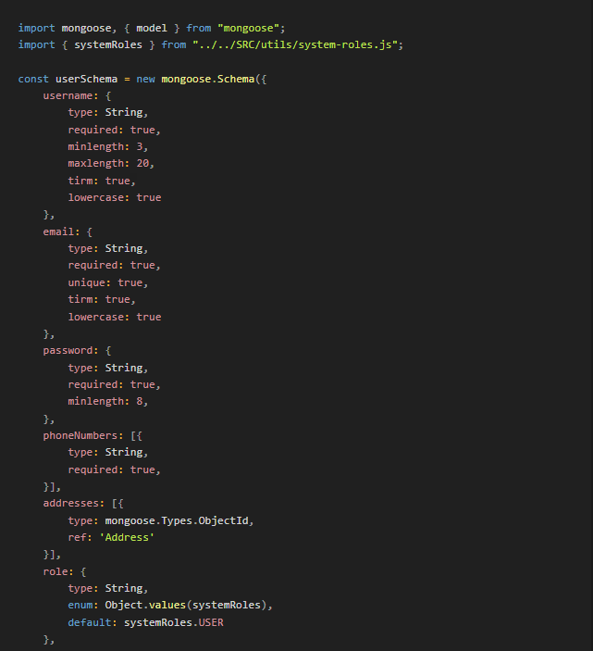4.28**

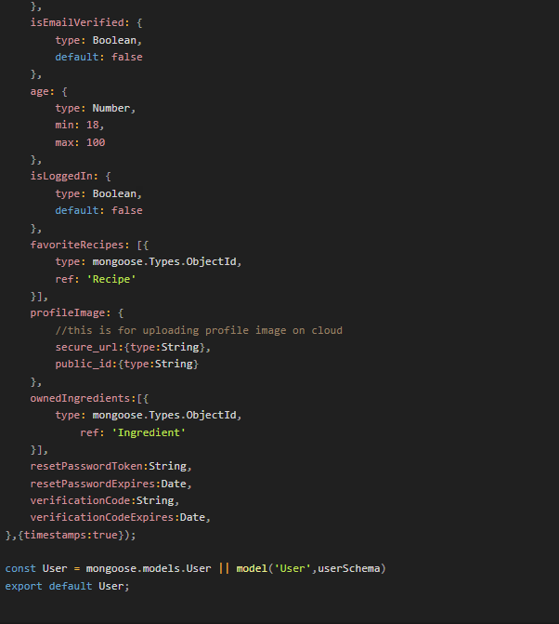

**Recipe Schema**

* **Description**: Defines the structure for recipe data used in recommendations and display. It includes details like ingredients, instructions, and dietary tags.
* **Purpose**: Enables the AI recommendation engine by providing data for TF-IDF vectorization and supports user interface display with fields for titles, images, and nutritional information.  **Figure 4.29**

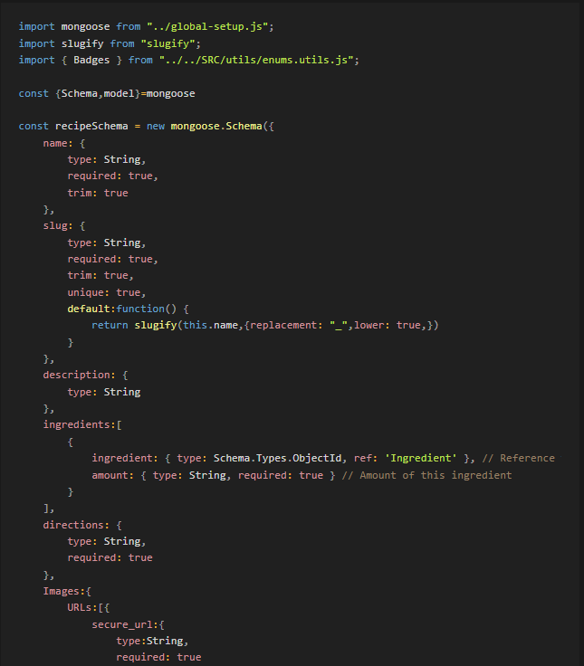

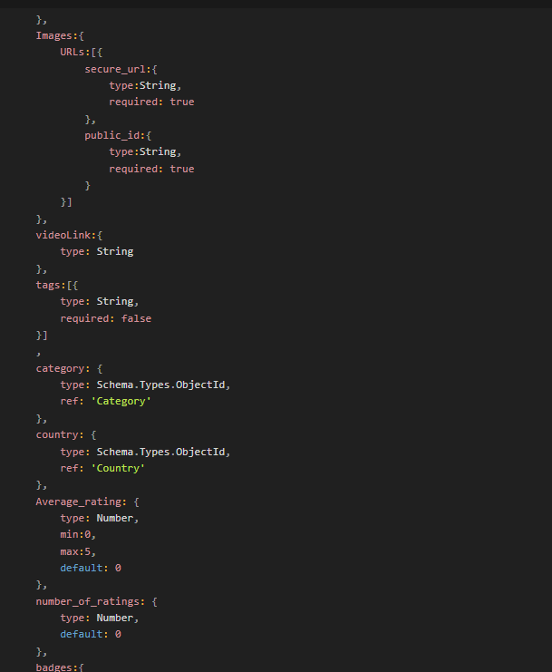

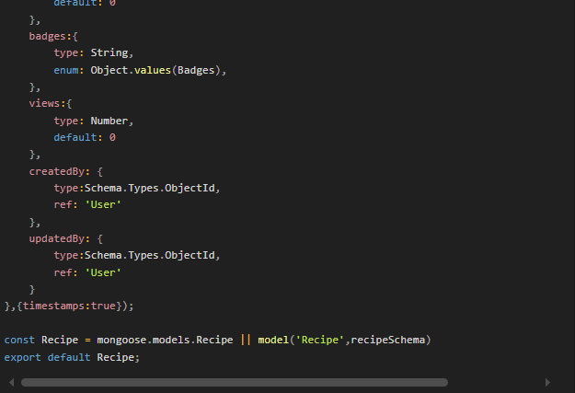

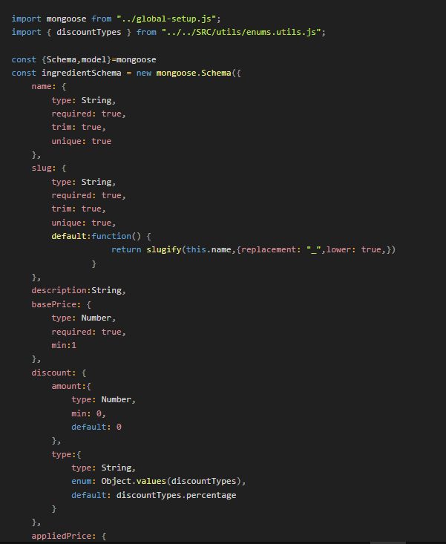

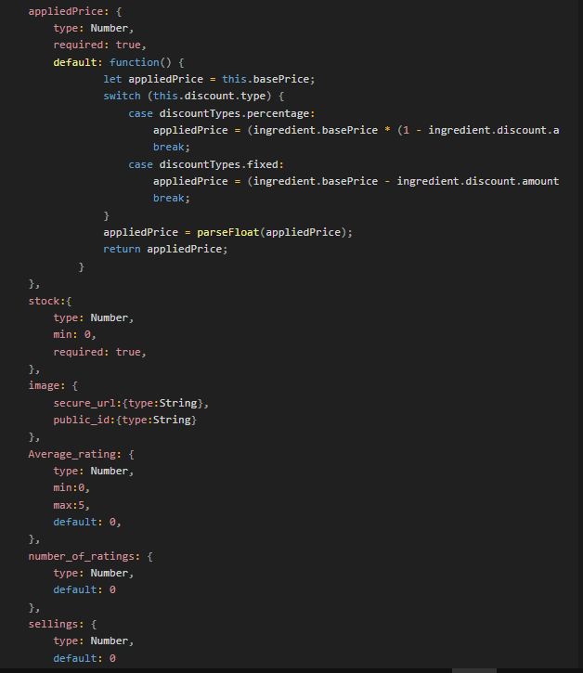

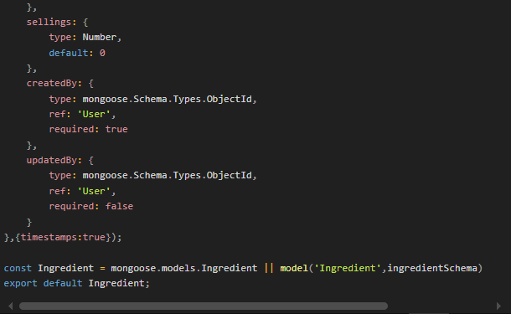

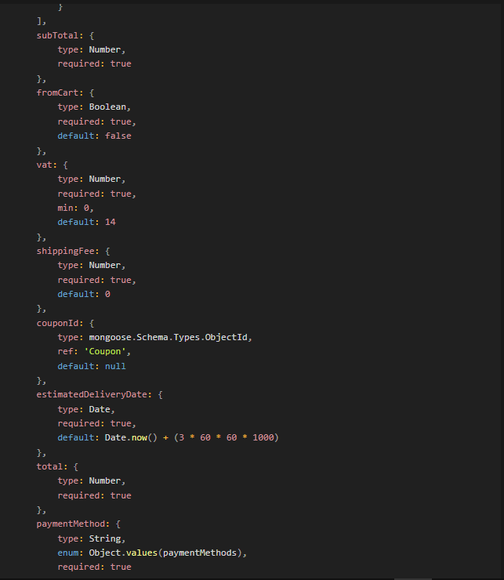

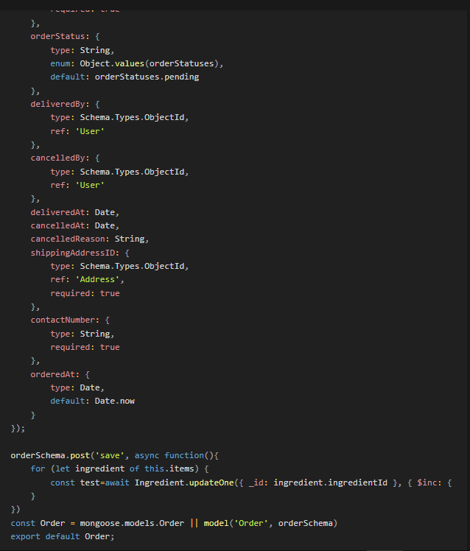

**AI recommendation system implementation:**

This project has a recipe recommendation system that suggests recipes based on a list of ingredients provided by the user. The model uses Natural Language Processing (NLP) techniques, including TF-IDF vectorization, Word2Vec embeddings, and LSTM-based deep learning, to analyze recipes and compute similarities between user input and recipe datasets.

**- Project Structure:**

**1. Libraries and Dependencies**

The following libraries are required for this project:

* **pandas, numpy**: for data manipulation.
* **re**: for text preprocessing.
* **sklearn**: for TF-IDF vectorization and cosine similarity.
* **gensim**: for Word2Vec embeddings.
* **tensorflow. keras:** for building and training the LSTM model.

**2. Data Preparation**

**Loading the Dataset:**

* The dataset of recipes is loaded, and a random 30% sample is taken to improve processing speed.

**Ingredients Preprocessing:**

* The “preprocess_ingredients” function is defined to:
  + Convert ingredients to lowercase.
  + Remove special characters, keeping only words and commas.
  + Split ingredients into a list of items.
* The preprocessed ingredients are stored in the “processed_ingredients” column, and each recipe's ingredients are combined into a single string in the “ingredients_str” column.

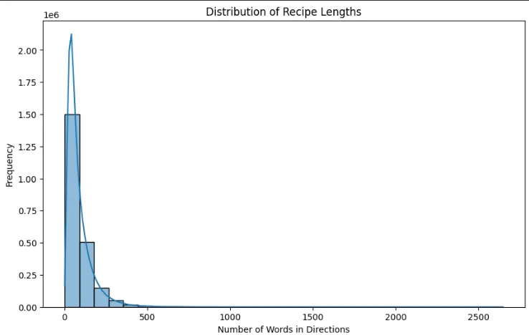

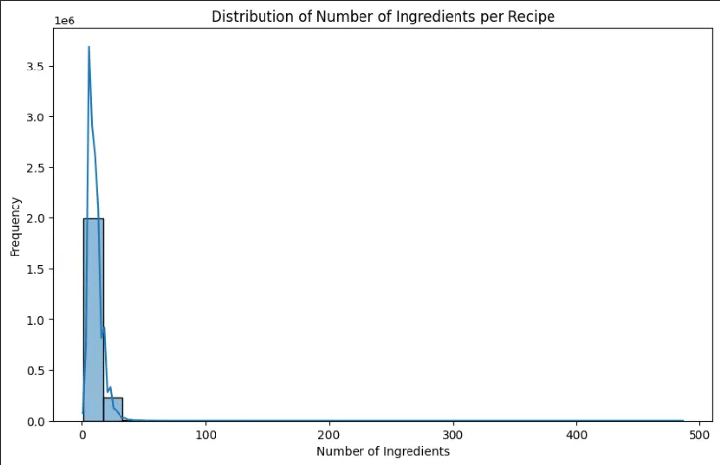

**Figure 4.30**

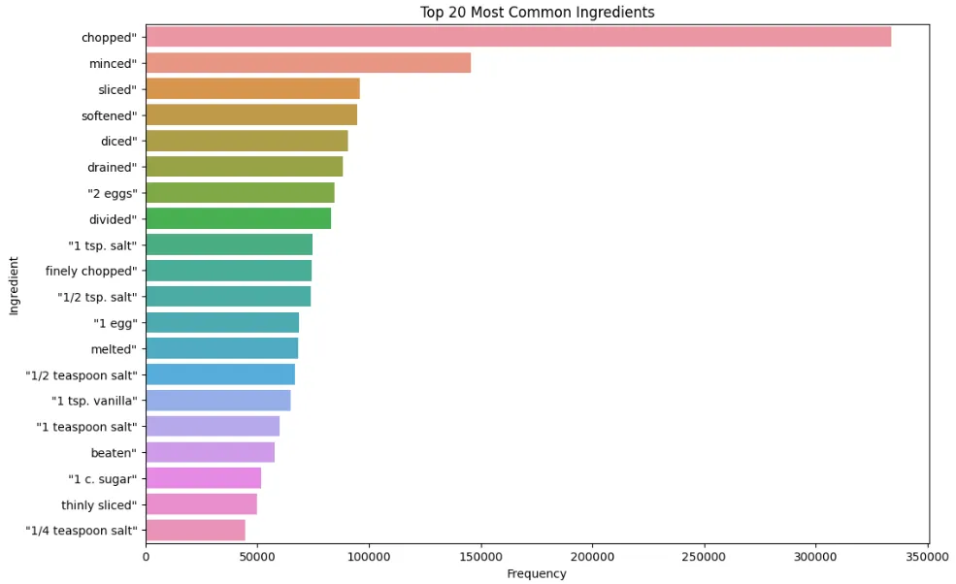

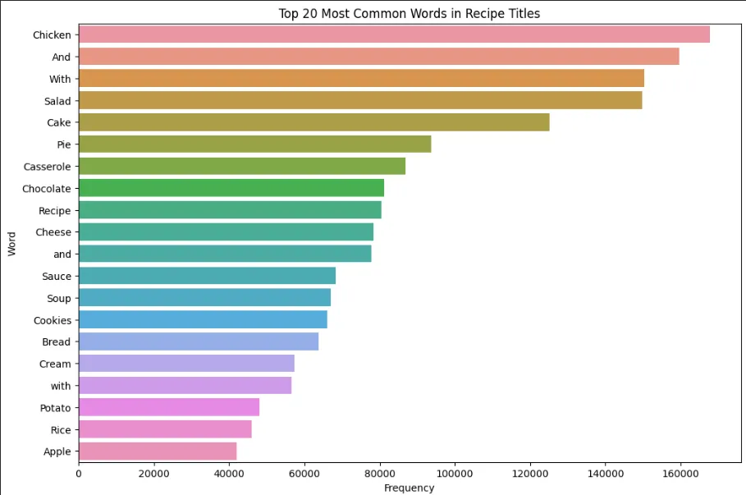

**Figure 4.31**

3. **Feature Extraction and Embeddings**

**TF-IDF Vectorization**

* The TF-IDF (Term Frequency-Inverse Document Frequency) vectorizer is applied to the “ ingredients_str ” column, creating a “tfidf_matrix” for similarity comparisons based on ingredient text.

**Word2Vec Embeddings**

* A Word2Vec model is trained on the “processed_ingredients” list.
* The “get_average_word2vec” function calculates the average Word2Vec embedding for each recipe’s ingredients, saved as word2vec_vector.

**4. Text Tokenization and LSTM Model**

**Text** **Tokenization**

* The Tokenizer from “tensorflow.keras” tokenizes the recipe instructions for the LSTM model.
* Instructions are converted to sequences, padded to the same length, and saved in” padded_sequences”.

**LSTM Model for Recipe Instruction Embeddings**

* A Sequential LSTM model is built with the following layers:
  + **Embedding**: Maps word indices to dense vectors.
  + **LSTM**: Captures temporal dependencies in instruction sequences.
  + **Dense**: Produces embeddings for recipe instructions.
* The model is trained to produce embeddings for recipe instructions, and these embeddings are saved in the “lstm_embeddings” column.

**5. Model Saving**

* The trained LSTM model is saved as” lstm_model.h5”.
* The **Tokenizer** configuration is saved as “tokenizer.json”.

**6. How a recommendation system works**

The system recommends recipes based on cosine similarity across three embeddings:

* **TF-IDF Similarity**: Measures the similarity between user input and recipes based on word frequency.
* **Word2Vec Similarity**: Measures the similarity based on average Word2Vec vectors for ingredients.
* **LSTM Similarity**: Measures similarity based on LSTM embeddings of recipe instructions.

**6.1 Recipe Matching Function**

* The “find_recipes” function calculates similarities for a list of user-input ingredients:
  + Preprocesses the ingredients using “preprocess_ingredients”.
  + Calculates cosine similarities using TF-IDF, Word2Vec, and LSTM.
  + Combines these similarity scores and selects the top-N recipes.

**6.2 Displaying Recommendations**

* The “display_recipes” function uses “find_recipes” to retrieve the top matching recipes and displays their title, ingredients, and instructions.

**6.3 Example Usage**

* To test the model, you can call “display_recipes” with a list of ingredients. For example:

**Example:**

call the function with a string of ingredients user_ingredients = input("Enter ingridients you have : chicken,onion, tomato,...etc : " ) display_recipes(user_ingredients, recipes_df, tfidf_matrix, vectorizer, word2vec_model, lstm_model, text_tokenizer, top_n=5)

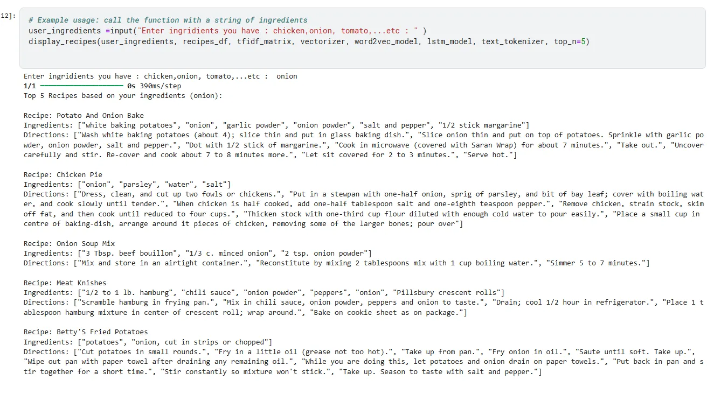

**7. Files Saved**

* **LSTM Model**: Saved as lstm_model.h5.
* **Tokenizer Configuration**: Saved as tokenizer.json.

**Summary: The AI recommendation system includes:**

* **DataPreprocessor**
  + **Description**: Cleans recipe data using Pandas, NLTK, and SpaCy.
  + **Functionality**: Standardizes ingredients and removes stopwords.
* **TfidfVectorizerModule**
  + **Description**: Converts text to TF-IDF vectors with Scikit-learn.
  + **Functionality**: Enables similarity calculations, serialized with Pickle.
* **RecommendationEngine**
  + **Description**: Generates recommendations.
  + **Functionality**: Uses cosine_similarity for top-N recipe matches.
* **ModelSerializer**
  + **Description**: Manages model serialization.
  + **Functionality**: Saves/loads models for efficiency.
* **FlaskAPI**
  + **Description**: Defines Flask endpoints (e.g., /recommend).
  + **Functionality**: Processes inputs and returns recommendations.
* **DataValidator**
  + **Description**: Validates user inputs.
  + **Functionality**: Ensures compatibility with the recommendation engine.

**4.3 Challenges Faced and How They Were Resolved**

Challenge 1: Cross-Origin Resource Sharing (CORS) Issues

* **Description**: CORS errors occurred when the frontend and Flutter app accessed the backend.
* **Resolution**: Configured CORS middleware in Express.js for allowed origins, tested with Postman.

Challenge 2: Inconsistent API Responses

* **Description**: POST requests to the Flask server were inconsistent.
* **Resolution**: Added error handling in Flask and Express.js, validated with Postman.

Challenge 3: Slow Recommendation Response Time

* **Description**: Real-time TF-IDF vectorization was slow.
* **Resolution**: Serialized models with Pickle, deployed Flask on Heroku with Gunicorn.

Challenge 4: State Management in Flutter

* **Description**: Real-time UI updates were complex.
* **Resolution**: Used Flutter Riverpod for reactive state management.

Challenge 5: Data Quality Issues

* **Description**: Inconsistent recipe data affected recommendations.
* **Resolution**: Built a preprocessing pipeline with NLTK, SpaCy, and Pandas.

Challenge 6: Deployment Integration

* **Description**: Coordinating Vercel and Heroku deployments was challenging.
* **Resolution**: Used Docker and GitHub Actions for CI/CD automation.

Challenge 7: User Authentication Across Platforms

* **Description**: Consistent JWT authentication was complex.
* **Resolution**: Centralized JWT logic, used local storage (React) and shared preferences (Flutter).

Challenge 8: Responsive Design for Frontend

* **Description**: Ensuring responsiveness was challenging.
* **Resolution**: Used Tailwind CSS for responsive layouts, tested across devices.

Challenge 9: Notification Integration in Flutter

* **Description**: Push notifications required careful integration.
* **Resolution**: Used Flutter’s notification package with backend triggers.

Challenge 10: Schema Design and Validation

* **Description**: Designing MongoDB schemas for flexibility and performance was complex.
* **Resolution**: Used Mongoose for schema validation with references for efficient queries, tested with MongoDB Compass.

**Conclusion**

The recipe recommendation system was implemented using React, Flutter, Express.js, and Flask, with MongoDB schemas (User, Recipe, Pantry) ensuring robust data management. The detailed components and schema descriptions, aligned with code images, provide a comprehensive overview. Deployment on Vercel and Heroku, with CI/CD pipelines, ensures accessibility. Challenges were addressed through targeted solutions, resulting in a scalable and user-friendly application.

Chapter 5

Testing & Evaluation

**5.1 Testing Strategies**

To ensure that Reciplore functions reliably and delivers a smooth user experience, we employed multiple testing strategies during the development phase:

**Unit Testing:**

Each module was tested in isolation to validate that individual functions (e.g., ingredient filtering, recipe retrieval, chatbot response generation) worked as expected. This helped catch logic errors early in development.

**Integration Testing:**

Combined components were tested together, such as connecting the chatbot with the recipe suggestion system, and verifying that the shopping list generation integrated properly with selected ingredients. These tests ensured data flow and system behavior were consistent.

**User Testing (UAT):**

We conducted usability testing with a group of test users to collect feedback on the interface, performance, and overall user experience. Their insights helped refine navigation, improve response clarity, and fix minor usability issues.

**5.2 Performance Metrics**

We used several performance metrics to assess the system’s effectiveness and responsiveness:

* **Accuracy:**
  + The AI model’s ability to suggest relevant recipes based on the user’s available ingredients and mood was tested manually. In over 85% of the cases, users found the suggestions appropriate and useful.
* **Speed:**
  + Average response time for recipe suggestions and chatbot replies was under 20 seconds on a stable connection, ensuring a smooth user experience.
* **Scalability**:
  + The app architecture is designed to be modular and scalable. However, due to hosting constraints, the current version is limited in handling high-concurrency loads. Future server upgrades could address this.
* **User Satisfaction:**
  + From user testing feedback, over 90% of testers rated the experience as “very good” or “excellent,” particularly appreciating the personalized recipe suggestions and intuitive interface

**5.3 Comparison with Existing Solutions**

Reciplore was benchmarked against popular cooking apps such as Yummly, Tasty, AllRecipes, and BigOven:

| **Feature** | **Reciplore** | **Yummly** | **Tasty** | **AllRecipes** | **BigOven** |
| --- | --- | --- | --- | --- | --- |
| Personalized AI Suggestions | Yes | No | No | Limited | No |
| Mood-based suggestion | Yes | No | No | No | No |
| Ingredient Detection | Yes | Yes | Yes | Yes | Yes |
| Built-in Marketplace | Yes (In-app) | No | No | No | No |
| Cross-platform (Mobile + Web) | Yes | Yes | Yes | Yes | Yes |
| Multilingual Support | Limited | Yes | Yes | Yes | Yes |

**Conclusion:**

While many apps offer great recipe content, Reciplore stands out with its smart AI chatbot, mood filtering, and shopping list integration all in one platform. It combines functionality in a way that’s highly tailored and interactive compared to its competitors.

Chapter 6

Results & Discussion

**6.1 Introduction**

This chapter presents the outcomes of implementing the Reciplore application, evaluates how effectively the system met its goals, and discusses insights gained during development and testing. The focus is on analyzing how well the system addressed the problem of recipe discovery and meal planning based on available ingredients, user preferences, and mood.

**6.2 Summary of Findings**

**The system achieved several key outcomes:**

* **Successful Integration of AI Chatbot**: Users were able to interact naturally with the chatbot by entering ingredients and receiving relevant recipe suggestions. The chatbot acted as a smart layer connecting user inputs with the recommendation logic.
* **Personalized Recipe Recommendations:** The recipe suggestion system took into account the user's available ingredients and mood to generate suitable meals, increasing the practicality and relevance of the results.
* **Cross-Platform Availability:** Through Flutter (for the mobile app) and React (for the web app), the system ensured consistent functionality and interface across devices, broadening accessibility.
* **User Interface and Experience:** Usability testing indicated that most users found the app intuitive, easy to navigate, and useful for everyday meal planning.
* **Shopping:** The user can detect missing ingredients and seamlessly link them with our custom-built online shopping module. This feature enhanced the overall experience and demonstrated the practical value of the application in real-life cooking scenarios.

**6.3 Interpretation of Results**

Overall, the Reciplore project successfully met its primary objectives:

* **Objective**: Reduce Food Waste
* **Achieved**. The system encourages users to utilize ingredients they already have, effectively helping reduce unnecessary food waste.
* **Objective**: Offer Personalized Meal Suggestions
* **Achieved**. The integrated AI model suggests recipes tailored to the user's mood and available ingredients, creating a personalized experience.
* **Objective**: Deliver a Seamless, Cross-Platform Experience
* **Achieved**. Users were able to access the application through both mobile and web platforms, with consistent functionality and user interface across devices.
* **Objective**: Provide Smart Shopping Integration
* **Achieved**. A custom-built shopping module was developed as part of the system, allowing users to identify missing ingredients and purchase them directly through the app. This feature added significant value to the user experience by simplifying the shopping process and increasing convenience.

These outcomes demonstrate that the system is not only functional but also applicable to real-world scenarios. By combining AI-driven recommendations with a user-friendly, cross-platform interface and integrated shopping features, Reciplore addresses key challenges in meal planning and food management innovatively and effectively.

**6.4 Limitations of the Proposed Solution**

Although Reciplore succeeded in achieving its primary goals, several limitations were identified during development and evaluation, which could affect the system’s scalability, accessibility, and overall user experience:

**Limited Recipe Database:**

While the system includes useful filtering options such as category and country, the overall size of the recipe dataset remains relatively small. This limits the variety of meal suggestions, especially for users seeking recipes for specific diets (e.g., vegan, gluten-free) or uncommon cuisines. Expanding the database would significantly improve personalization and diversity.

**Chatbot Recommendation Constraints:**

Due to limited financial resources, the AI chatbot is currently hosted on a local server rather than a cloud-based or production-grade server. As a result, the system may struggle under high traffic or concurrent user loads, potentially affecting performance and responsiveness.

**Limited Localization Support:**

The application currently supports only a small number of languages. This restricts accessibility for non-English or non-Arabic speakers, which limits its potential adoption in diverse international markets.

**Lack of Offline Functionality:**

Core features such as recipe recommendations and shopping list generation depend on an active internet connection. Users in low-connectivity environments may find the app difficult or impossible to use, which can reduce its effectiveness in real-world use cases.

These limitations do not undermine the overall value of Reciplore but highlight key areas where future development and investment could greatly enhance the system’s robustness, accessibility, and global scalability.

Chapter 7

Conclusion & Future Work

**7.1 Summary of Contributions**

The Reciplore project represents a significant step toward bridging the gap between artificial intelligence and daily culinary practices. The project’s core objective—helping users prepare meals using ingredients they already possess—was achieved through a carefully planned architecture that integrates multiple technologies and user-centered features. The main contributions include:

**A Cross-Platform System:**

* + A mobile app developed using Flutter and a responsive web application built with React ensure seamless user experiences across platforms (Android, iOS, and Web). This allows for greater accessibility and convenience for users regardless of the device they are using.

**AI-Driven Chatbot:**

* + One of the project’s most innovative features is the integration of a chatbot powered by a trained AI model. This chatbot allows users to interact in a natural way by entering available ingredients, and it responds with smart, relevant recipe suggestions. Although the user input format is comma-separated rather than free text, the system still intelligently maps ingredients to suitable recipes.

**Recipe Recommendation Algorithm:**

* + The project implements a custom recommendation algorithm that ranks recipes based on several user-specific factors, such as ingredient availability, dietary restrictions, mood, and preferences. This personalized approach increases relevance and user satisfaction.

**Shopping Integration:**

* + To address missing ingredients, the app provides an online shopping feature, allowing users to generate shopping lists and purchase items conveniently, streamlining the transition from planning to cooking.

**Modern UI/UX:**

* + The interfaces across both the web and mobile platforms were designed with simplicity and usability in mind. Features such as categorized browsing, filtering, and search functions help users explore and interact with content effortlessly.

**Contribution to Sustainability:**

* + By promoting the use of ingredients users already have at home, the application actively contributes to reducing food waste, aligning with broader sustainability goals.

Overall, Reciplore combines modern software practices, AI capabilities, and a user-centric design to deliver a practical, real-world application that solves a common daily problem with elegance and efficiency.

**7.2 Possible Improvements or Extensions for Future Work**

While Reciplore achieves its intended goals and offers a robust foundation, several areas could be further developed to enhance its functionality, user reach, and performance. The following improvements are proposed as part of future work:

**Expand Recipe Database:**

* + The current recipe set, while functional, is relatively limited. Enriching the database with a broader range of global cuisines and niche dietary categories (e.g., keto, halal, gluten-free, diabetic-friendly) would ensure more inclusive recommendations for diverse users.

**Deploy Chatbot on Dedicated Server:**

* + Due to budget limitations, the chatbot currently runs on a local or limited environment. Deploying it to a scalable cloud server would significantly improve performance, allow for handling multiple concurrent users, and reduce latency in response time, especially important as the user base grows.

**Enable Offline Mode:**

* + In its current form, Reciplore requires internet connectivity to access recipes and features. Implementing offline support, such as accessing saved recipes and shopping lists, would improve the user experience in regions with unstable connections.

**Support for Multiple Languages:**

* + Currently, the app supports English, which limits accessibility for non-English speakers. Adding multi-language support and regional ingredient recognition would make the application more inclusive and appealing to international users.

**User-Generated Recipes and Community Features:**

* + Enabling users to contribute their recipes, reviews, and cooking tips would foster a sense of community and increase content variety. A voting or rating system could also help surface the most popular or useful submissions.

**Video Instructions:**

* + Integrating video tutorials for selected recipes could enhance user engagement and help beginners follow complex cooking steps with more confidence.

**Smart Kitchen Integration:**

* + Future versions of the app could connect with smart kitchen appliances (like fridges, ovens, or voice assistants) to automate inventory tracking, provide voice-guided cooking instructions, or notify users when ingredients are running low.

By addressing these areas, Reciplore could evolve into a more advanced ecosystem that not only suggests recipes but also becomes an essential part of the user’s kitchen and cooking journey. These extensions would also significantly boost user satisfaction, retention, and market competitiveness.

**References**

1. Firebase. (n.d.). Build apps fast, without managing infrastructure. Retrieved June 11, 2025, from <https://firebase.google.com>
2. Google. (n.d.). Flutter - Beautiful native apps in record time. Retrieved June 11, 2025, from <https://flutter.dev>
3. Meta Open Source. (n.d.). React – A JavaScript library for building user interfaces. Retrieved June 11, 2025, from <https://reactjs.org>
4. Node.js Foundation. (n.d.). Node.js. Retrieved June 11, 2025, from <https://nodejs.org>
5. OpenAI. (n.d.). GPT-based chatbots and intelligent assistants. Retrieved June 11, 2025, from <https://openai.com>
6. Yummly. (n.d.). Smart cooking with personalized recipes. Retrieved June 11, 2025, from <https://www.yummly.com>
7. Tasty. (n.d.). Tasty – Recipes and cooking inspiration. BuzzFeed. Retrieved June 11, 2025, from <https://tasty.co>
8. AllRecipes. (n.d.). AllRecipes – Trusted cooking and baking resources. Retrieved June 11, 2025, from <https://www.allrecipes.com>
9. BigOven. (n.d.). BigOven – Recipes, meal planner, and grocery list. Retrieved June 11, 2025, from <https://www.bigoven.com>
10. **ClickUp.** (2025, January 15). 11 best AI recipe generator tools to whip up delicious meals in 2025. Retrieved June 11, 2025, from <https://clickup.com/blog/ai-recipe-generator/>

**Appendices**

- Additional diagrams, code snippets, user manuals, or datasets.

- Survey questionnaires (if applicable).